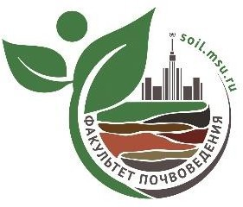

**Lomonosov Moscow State University**

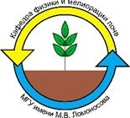**Soil Science Faculty**

**Russian Society of Soil Scientists**



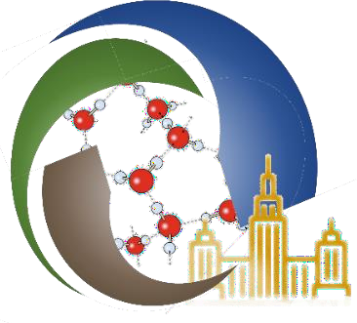**II INTERNATIONAL INTERDISCIPLINARY SCIENTIFIC YOUTH FORUM**

**STRUCTURAL AND FUNCTIONAL UNITY OF SOILS AND ADJACENT ENVIRONMENTS**

**dated to the 270th anniversary of Lomonosov Moscow State University**

**1st INFORMATION LETTER**

***Dear colleagues!***

The Soil Science Faculty of Lomonosov Moscow State University invites you to participate in the II International Youth Forum "Structural and Functional Unity of Soils and Adjacent Environments". The Forum, which will take place in Moscow at on **July 19-25** **2025.**

The scientific program of the Forum is based on the interdisciplinary nature of soil science and is devoted to issues of modern and promising applications of fundamental concepts of soil science and related fields. It aims to unite young scientists studying in different programs related to research of soils and adjacent environments, to discuss advanced scientific experience, discuss prospects for development and cooperation.

**Working languages:** Russian, English.

The forum will be held in the format of lectures by leading scientists, scientific excursions, field master classes, a poster session and discussion tables/debate.

## 

## PLANNED WORKING AREAS OF THE DISCUSSION TABLES/ DEBATE

1. Acquisition of agricultural land, forests, parts of national parks, etc. by megalopolises (developers)
2. Urban agronomy in new suburban zones: pro and contra

## 

## PLANNED AREAS OF REPORT TOPICS OF THE POSTER SESSION

1. Urban Meteorology
2. Hydrothermal regimes of soils
3. Factors, mechanisms and markers of biodiversity and sustainability of ecosystems
4. Health of the urban environment
5. Modern technologies and tools applied to soil sciences
6. Soil health: indicators, descriptors, attributes and the ways to improve
7. Hydropedology in urban context

## CONFERENCE PRESIDENT

|  |  |
| --- | --- |
| ***Aminat Umarova*** | Professor, Head of Department of Soil Physics and Reclamation, Soil Science Faculty of Moscow State University, Moscow, Russia |
| ***Said Al-Ismaily*** | PhD Soil Sciences, Head of Department of Soils, Water & Agricultural Engineering College of Agricultural & Marine Sciences, Sultan Qaboos University, Al‐Khoud, Sultanate of Oman |

## EXECUTIVE SECRETARY

|  |  |
| --- | --- |
| ***Konstantin Romanenko*** | Department of Soil Physics and Reclamation, Scientific Secretary of the V.V. Dokuchaev Society of Soil Scientists |

## ORGANISING COMMITTEE (Soil Science Faculty of Moscow State University)

|  |  |
| --- | --- |
| ***Anastasia Gasina*** |  |
| ***Amalia Tazieva*** | |
| ***Anastasia Meltsaeva*** | |
| ***Anastasia Toskhoporan*** | |
| ***Artem Sadykov*** | |
| ***Daniil Mitichkin*** | |
| ***Daria Tsukankova*** | |
| ***Larisa Arakelova*** | |
| ***Maria Kochneva*** | |
| ***Riana Akhmetzyanova*** | |
| ***Svetlana Klushina*** | |
| ***Timofey Kalnin*** | |

## 

## PROGRAM COMMITTEE

|  |  |
| --- | --- |
| ***Afrah Al-Shukaili*** | PhD Soil Sciences, Department of Soils, Water & Agricultural Engineering College of Agricultural & Marine Sciences, Sultan Qaboos University, Al‐Khoud, Sultanate of Oman |
| ***Alexander Rappoport*** | PhD, Moscow State Botanical Garden |
| ***Andrey Smagin*** | Prof., Department of Soil Physics and Reclamation, Soil Science Faculty of Moscow State University, Moscow, Russia |
| ***Anna Fedotova*** | Prof., Federal Scientific Center of Agroecology of the RAS, Volgograd, Russia |
| ***Anna Ivanova*** | PhD, Department of Soil Biology, Soil Science Faculty of Moscow State University, Moscow, Russia |
| ***Anna Kokoreva*** | PhD, Department of Soil Physics and Reclamation, Soil Science Faculty of Moscow State University, Moscow, Russia |
| ***Ekaterina Makarova*** | PhD, Department of Soil Physics and Reclamation, Soil Science Faculty of Moscow State University, Moscow, Russia |
| ***Elena Tikhonova*** | PhD, Head of Department of Landscape Architecture and Soil Science, Voronezh State Forest Engineering University, Voronezh, Russia |
| ***Larisa Pozdnyakova*** | PhD, Landviser LLC, Houston, Texas, USA |
| ***Marina Butylkina*** | PhD, Department of Soil Physics and Reclamation, Soil Science Faculty of Moscow State University, Moscow, Russia |
| ***Marina Rozanova*** | PhD, Department of Soil Chemistry, Soil Science Faculty of Moscow State University, Moscow, Russia |
| ***Mikhail Mazirov*** | Prof., Russian State Agrarian University - Moscow Timiryazev Agricultural Academy, Moscow, Russia |
| ***Olga Yakimenko*** | PhD, Department of Soil Chemistry, Soil Science Faculty of Moscow State University, Moscow, Russia |
| ***Vladimir Goncharov*** | Prof., Department of Soil Physics and Reclamation, Soil Science Faculty of Moscow State University, Moscow, Russia |

## Address of the organizing committee: 119991, Moscow, GSP-1, Leninskie Gory, M.V. Lomonosov Moscow State University, 1, building 12, Faculty of soil science

## Tel./fax: (495) 9393684

## e-mail: youth.soil.forum@yandex.ru

## Forum information can be found on the Internet at the link:

https://lomonosov-msu.ru/rus/event/9812/

## MAIN DATES

|  |  |
| --- | --- |
| April 30 | Sending out the 1st Information letter, start of electronic registration at the link |
| June 30 | Sending out the 2nd Information letter and preliminary Forum program |
| July 19 | Start of registration of Forum participants  Forum opening |
| July 21-25 | Forum work |
| July 25 | Forum closing |

Registration of participants in the listener format on the website: <https://lomonosov-msu.ru/rus/event/9812/> is possible until July 21, 2025 inclusive.

## CONFERENCE PROGRAM

The preliminary program of the conference will be sent out in the 2nd Information letter.

## ACCOMODATION

Organizing Committee recommends that the conference participants book their own accommodation in Moscow using booking services. We strongly advise you to do this in the near future, due to the beginning of the active tourist season in Moscow.

Organizing Committee does not provide visa support.

We give some conveniently located hotels as an example (the organizing committee does not undertake the obligation to register participants in them):

Standard hotels

1. The Salyut Hotel. https://hotelsalut.ru. Rooms from 50 Euro per night. The metro

is a 15-20-minute walk away.

1. Mini-hotel Orange on Akademicheskaya. In the ancient Cheryomushki manor.

There is a tram going to Moscow State University nearby. Rooms from 40 Euro.

http://orangehotels.ru/?yclid=641190943857082188#akademicheskaya

1. The Orange Hotel on the Southwest. There is a subway nearby. Rooms from 40

Euro. http://orangehotels.ru/?yclid=641190943857082188#yugozapadnaya

1. Mini-hotel "Akademik" Rooms from 40 Euro. http://1arbat-hotel.ru/hotel-akademik/

Economy option

1. The University Hotel. Cheap and walking distance. The cost starts from 30 Euro per night. <http://www.uhtl.ru/>

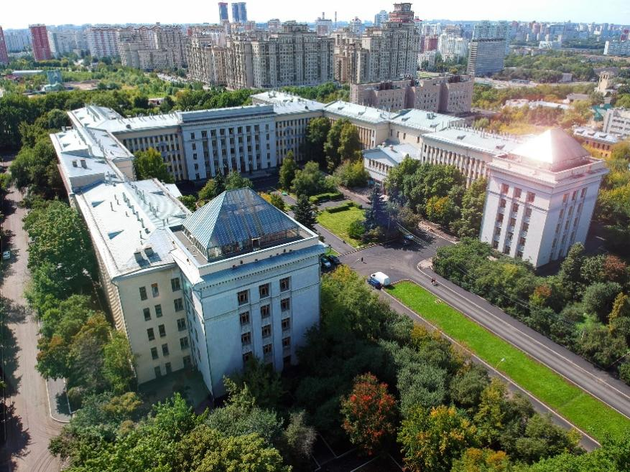

**We are looking forward to welcoming you at the Forum!**

**Organising Committee**