The stability constants prediction of thorium complexes based on machine learning methods
Feng Shide
PhD Student, 2nd year
Chemistry Department, Shenzhen MSU-BIT University
No. 1 International University Park Road, Longgang District
Shenzhen 518172, Guangdong, China
E-mail: sf373847724@outlook.com
In recent years, the machine learning method is applied for the ligands research, it is more efficient than the DFT system during the selection processes. The random forest method is applied in this work.
Recent research shows that there are successful cases for prediction of ligand, the scholars in the world work in different angles such as large dataset research [1], feature engineering [2] optimization of algorithm [1, 3].
The data set contains 119 samples of LogK, the range is between 0.18 to 41.72. The sample is divided in three parts, 60% of data is training data group, 20% of data is validation group, 20% of data is test group. About the parameters of the model, the n estimator is 50, maximum depth of tress is 5, minimum sample split is 10.
The results show appliable ability of prediction, the R² of Training data group is 0.83, the R² of the validation data group is 067, the R² of the test data group is 0.71, the MAE is between 2.08 to 2.81, the stability of the prediction is relatively accurate based on the small data set. The MAPE is high, because there are some samples that are very close to 0. ΔR² is 0.11, although it is a very slight overfitting issues, but it is common for small samples size dataset. The residuals distribution is close to the center, there is no sign of Heteroskedasticity.

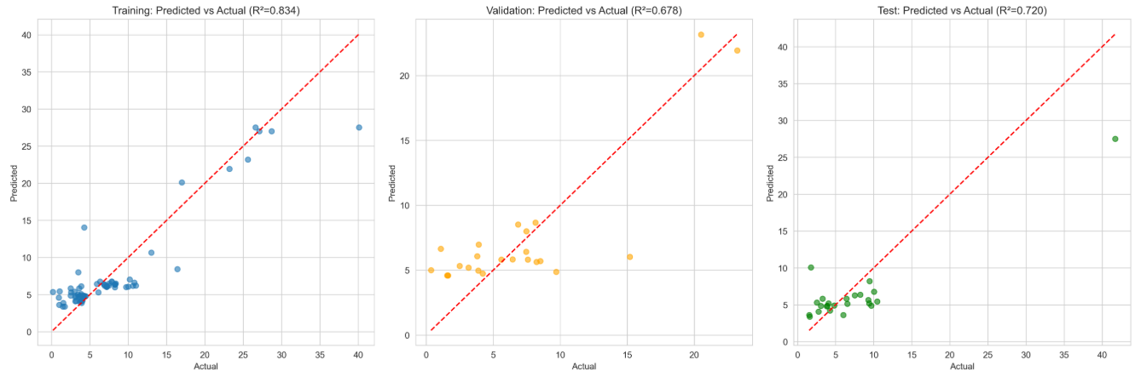
Fig. 1. The comparison of actual values and predicted values of stability constants.

In general, although the dataset is small, this model is applicable for selection, the optimization work will be conducted in the future.
Literature
1. Zhang Q., Wang H., Liu Z., Hao Z., Liao W. Predicting rare earth extraction efficiency with organophosphorus ligands: A data-driven machine learning approach // Journal of Rare Earths. 2025
2. Chaube S., Goverapet Srinivasan S., Rai B. Applied machine learning for predicting the lanthanide-ligand binding affinities // Scientific reports. 2020. Vol. 10(1). P. 14322.
3. Park K. C., Lim J., Thaggard G. C., Shustova N. B. Mining for Metal–Organic Systems: Chemistry Frontiers of Th-, U-, and Zr-Materials // Journal of the American Chemical Society. 2024. Vol. 146(27). P. 18189-18204.

