Investigation of novel triphenylamine hole transport wide-bandgap perovskite solar cells
Zhukov I.A.¹, Akkuratov A.V.², Luchkin S.Y. ¹, Tepliakova M.M. ¹
Student, 1st year master's degree program
¹Skolkovo Institute of Science and Technology, Moscow, Russia
²Federal Research Center for Problems of Chemical Physics and Medicinal Chemistry RAS, Chernogolovka, Russia
E-mail: Ivan.Zhukov@skoltech.ru
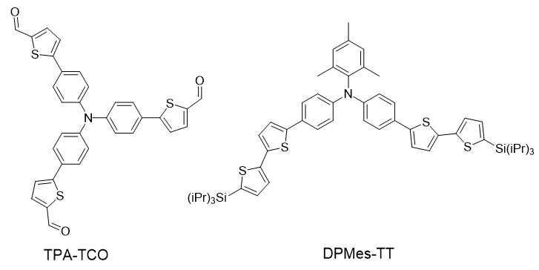
Wide-bandgap perovskite solar cells (wPSCs) with bandgap E_{g}>1.8 eV are gaining popularity due to possible application in tandem solar cells with improved efficiency. Mostly photovoltaic devices with wide-bandgap perovskites comprise the same hole transport material (HTM) as devices with standard perovskite CH₃NH₃PbI₃ (E_{g} = 1.4 eV) [1]. This results in a mismatch between the highest occupied molecular orbital (HOMO) energy level of the HTM and the perovskite, which leads to energy losses during charge transfer and entails a significant reduction in device efficiency. Therefore, there is an urgent need for the design of HTMs possessing deeper lying HOMO energy level enabling alignment with wide bandgap perovskites. In this work, we investigated novel triphenylamine based HTMs 5,5',5''-(nitrilotris(benzene-4,1diyl))tris(thiophene-2-carbaldehyde) (TPA-TCO) and 2,4,6-trimethyl-N,N-bis(4-(5'(triisopropylsilyl)-[2,2'-bithiophen]-5-yl)phenyl)aniline (DPMes-TT) with a promising widebandgap perovskite Cs_{0.05}(CH₃NH₃)_{0.15}(CH(NH₂)₂)_{0.8}Pb(I_{0.75}Br_{0.25})₃ [2].
Fig. 1. Structure of TPA-TCO and DPMes-TT molecules
First, thin films based on TPA-TCO and DPMes-TT were investigated with a set of techniques to evaluate their suitability for p-i-n wPSCs. The wettability of the thin films by the perovskite solution was evaluated to ensure the formation of high-quality photoactive layers on top. The optical absorbance of the obtained films was analyzed using UV–vis spectroscopy. The quality and uniformity of the HTM films after DMF washing were confirmed by atomic force microscopy.
In the next step, devices with various configurations incorporating the investigated HTMs and wide-bandgap perovskites were fabricated. The best characteristics were achieved with the configuration Indiumtin oxide/NiO_{x}/HTM/Cs_{0.05}(CH₃NH₃)_{0.15}(CH(NH₂)₂)_{0.8}Pb(I_{0.75}Br_{0.25})₃/ [6,6]-phenyl-C₆₁-butyric acid methyl ester/Mg/Ag. The study of photoluminescence and timeresolved photoluminescence spectra showed that the higher efficiency of the device with the studied materials may be associated with better passivation of physical impact defects. Our study confirmed the potential of triphenylamine based HTMs for the application in p-i-n wPSCs.
This work was supported by a joint grant from NJU-Skoltech (Project 1-NJU-0005)
Reference
1. Hang P., et al. Highly efficient and stable wide‐bandgap perovskite solar cells via strain management //Adv. Func. Mater. 2023. Vol. 33. P. 11.
2. Ning S., et al. Reinforcing the Buried Interface Enables Efficient and Stable Wide‐Bandgap Perovskite Solar Cells for Perovskite/Silicon Tandems //Adv. Optical Mater. 2025. Vol. 13. P. 32.

