**Synthesis of azoloisoquinolines based on amino acids**

***Mirzokulov S.M., Yusupov A.B., Tukhtaev D.B.***

*Master student Department of Chemistry Samarkand state university*

*Samarkand state university, Samarkand, Uzbekistan*

E-mail: [*mirzokulovsm@gmail.com*](mailto:mirzokulovsm@gmail.com)

Heterocyclic compounds are important building blocks for natural bioactive substances and advanced materials. Heterocyclic compounds contain various heteroatoms, in particular heterocyclic compounds containing nitrogen [1] show high bioactivity and various pharmacological properties, and they are used in agriculture as many agrochemical drugs.

The isoquinoline nucleus is a natural bioactive and an important component of widely used drugs. Substances formed by the condensation of the azolo group on the isoquinoline nucleus attract researchers due to their diversity and biological activity, for example, showing anticancer, antibacterial, antimalarial and anti-inflammatory properties [2,3].

Our research is focused on the synthesis and modification of azoloisoquinolines through amino acid-based intermediates [4], and it is important to protect the amino group and continue the reactions with the carboxyl group at the initial stage.

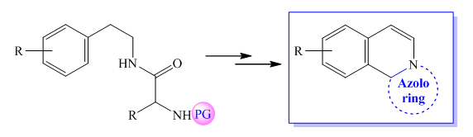

It was studied that the synthesis of azoloisoquinolines can be carried out in 3 stages, and in the last stage of the reaction, the corresponding products were formed as a result of ring reactions of N-protected amino acids. This method can be one of the simple and alternative methods of synthesizing azoloisoquinolines.

**References:**

1. Marcus Baumann, Ian R. Baxendale, Steven V. Ley and Nikzad Nikbin. An overview of the key routes to the best selling 5-membered ring heterocyclic pharmaceuticals. *Beilstein J. Org. Chem.* 2011, *7,* 442–495.
2. Shenvi S, Kumar K, Hatti KS, Rijesh K, Diwakar L, Reddy GC (2013) Synthesis, anticancer and antioxidant activities of 2,4,5-trimethoxy chalcones and analogues from asaronaldehyde: Structure–activity relationship. *Eur J Med Chem 62:435–442*
3. Elwan NM, Abdelhadi HA, Abdallah TA, Hassaneen HM (1996) Synthesis of [1,2,4]triazolo[3,4-a]isoquinolines and pyrrolo[2,1-a]isoquinolines using α-keto hydrazonoyl halides. *Tetrahedron 52:3451–3456*
4. Tukhtaev D., Yusupov A., Vinogradova V. Synthesis of new Amides based on NPhthaloyl-α-Amino Acids //*Egyptian Journal of Chemistry. – 2021. – V. 64. – №. 6. – P. 3049-3058.*