**An efficient method for the synthesis of sterically hindered nitroxyl radicals by interaction of sterically loaded nitrons with alkynyl magnesium halides**

***Gulman M.M.1,2***

*Student, 4th year of the specialty*

*1Novosibirsk State University,* d*epartment of Natural Sciences, Novosibirsk, Russia*

*2N. N. Vorozhtsov Novosibirsk Institute of Organic Chemistry SB RAS, Novosibirsk, Russia*

*E-mail: mihajomark@gmail.com*

Nitroxides are a type of stable organic radicals that have been widely used to solve biophysical problems. The stability of the nitroxyl group is essential for studying the structure of biological macromolecules inside living cells. The with sterically hindered pyrrolidine nitroxides with bulk substituents (greater than methyl) in the 2 and 5 positions of the heterocycle are the most promising objects for creating spin labels and probes. This is due to their high stability to reduction by biogenic systems [1].

Classical methods of sterically hindered pyrrolidine nitroxides synthesis based on Favorskii rearrangement involve expensive starting reagents and result in low total yields of the target radicals. Obtaining sterically hindered nitroxides of the pyrrolidine series by interacting sterically hindered nitrones with various Grignard reagents is not feasible due to the predominant occurrence of deoxygenation processes [1, 2].

Scheme 1. Synthesis of sterically hindered nitroxyl radicals

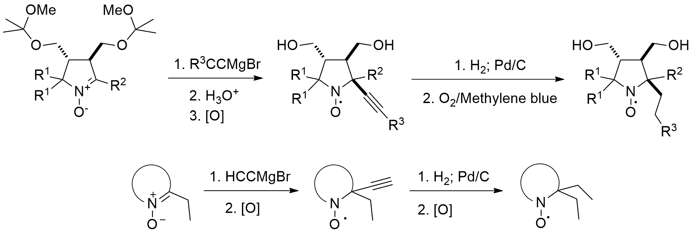

An alternative method for synthesising sterically hindered radicals has been proposed. This involves the interaction of sterically loaded ketonitrons with alkynylmagnesium bromides, which leads to hydroxylamine. Oxidation of the hydroxylamine produces a nitroxyl radical with an α-alkynyl group. The final step is to hydrogenate the multiple carbon-carbon bond, followed by regeneration of the nitroxide moiety.

*This research was funded by the Russian Science Foundation (grant number 22-73-00098)*

**Literature**

1. Dobrynin S. A. et al. A simple method of synthesis of 3-carboxy-2, 2, 5, 5-tetraethylpyrrolidine-1-oxyl and preparation of reduction-resistant spin labels and probes of pyrrolidine series //Molecules. – 2021. – Vol. 26. –N. 19. – P. 5761.

2. Taratayko A. I. et al. 3, 4-Unsubstituted 2-tert-Butyl-pyrrolidine-1-oxyls with Hydrophilic Functional Groups in the Side Chains //Molecules. – 2022. – Vol. 27. – N. 6. – P. 1922.