**VVER-1200 Reactor Core Pin Cell Steady-State Thermal Hydraulics Analyses and Cross-Validation**

***Siro R.F.***

*Student, Bachelor’s Degree (Nuclear Engineering and Thermal Physics)*

*National Research Nuclear University (IATE NRNU MEPhI), Department of Nuclear Physics and Engineering, Obninsk, Russia*

*E-mail: folkenbergsr20@oiate.ru*

Reactor core components are designed with materials capable of facilitating heat transfer while withstanding very high thermal stresses. The purpose of this research work is to verify by cross-validation, the thermal hydraulic processes associated with different material layers that constitute the VVER-1200 reactor core pin cell. This is to ascertain the reactor coolant performance and the safety of the VVER-1200 by analyzing the heat transfer on fuel elements along the radial axis during steady-state conditions, taking into account the computed thermophysical properties, some of which are indicated in figure 2. The reactor core pin cell material layers under investigation include the central hole, fuel, gas gap, cladding and the coolant as shown in figure 1 below.

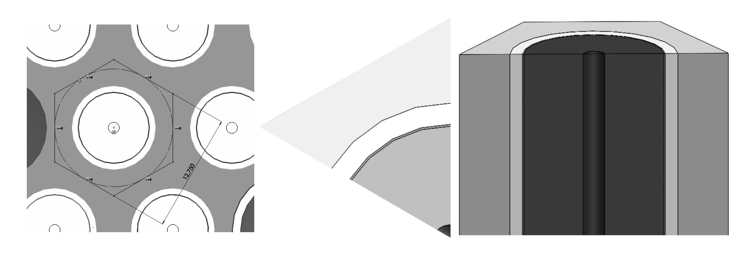**Fig. 1.** VVER-1200 reactor core pin cell material layers

We perform thermal hydraulic analyses of the VVER-1200 reactor core pin cell by solving the general heat conduction equation 1 for each material layer in the pin cell [2].

$\frac{1}{r}⋅\frac{∂}{∂r}\left(λ⋅r\frac{∂T}{∂r}\right)+\frac{1}{r^{2}}⋅\frac{∂}{∂ϕ}⋅\left(λ⋅r\frac{∂T}{∂ϕ}\right)+\frac{∂}{∂z}\left(λ\frac{∂T}{∂z}\right)+q_{v}=ρ⋅C_{p}\frac{∂T}{∂t}$ (1)

Where: $λ$, $C_{p}$, $T$, $q_{v}$, $ρ$, and $r$ are thermal conductivity, isobaric specific heat capacity, temperature, volumetric local heat flux density, material physical density and layer radius respectively.

Thermal hydraulic analysis is a crucial procedure in the adoption of the safety standards of nuclear reactors [1]. It is also crucial in the design phase of a nuclear reactor, during which the fuel rod modeling gives information on the heat transfer coefficient between the central hole and the fuel pellet, the fuel pellet and the cladding through the gas gap, and ultimately from the surface of the fuel cladding to the coolant. From these calculations, we establish the power produced by the reactor core and its removal by the coolant. During the analyses, we verify and ascertain the safety of the VVER-1200 by studying the behaviour of heat transfer along the radial axis of the pin cell. In order to ensure that the integrity of the reactor core sub-assembly is not compromised, the thermophysical properties of associated materials are chosen very carefully in the preliminary calculations.

UO2 is a fascinating material in this study in the sense that it exhibits low thermal conductivity, a behaviour that would result into formation of cracks in the pellet, however, it compensates for this nuisance with a significantly high melting point. The thermal conductivity of UO2 dictates the nature of the temperature difference between the center-line temperature and the surface temperature during the removal of fission heat from the fuel. A poor thermal conductivity of the fuel would thus result into a large temperature difference. In the VVER-1200, the gas gap constitutes He gas. Both of the fuel and the gas gap materials exhibit low thermal conductivities, but this is compensated for by significantly reducing the gas gap thickness and introducing a cladding material layer, E-110 with a significantly high thermal conductivity in order to allow rapid heat transfer from the fuel element to the coolant.

The adopted methodology involves initially performing preliminary thermophysical calculations associated with the pin cell material layers to prepare thermal hydraulics analyses input data and boundary conditions. In this case, the isobaric specific heat capacity, thermal conductivity and physical density associated with the fuel, the gas gap material, the cladding and the coolant are computed from empirical correlations [3]. Some results of the first stage are presented in the form of graphical plots in figure 2.

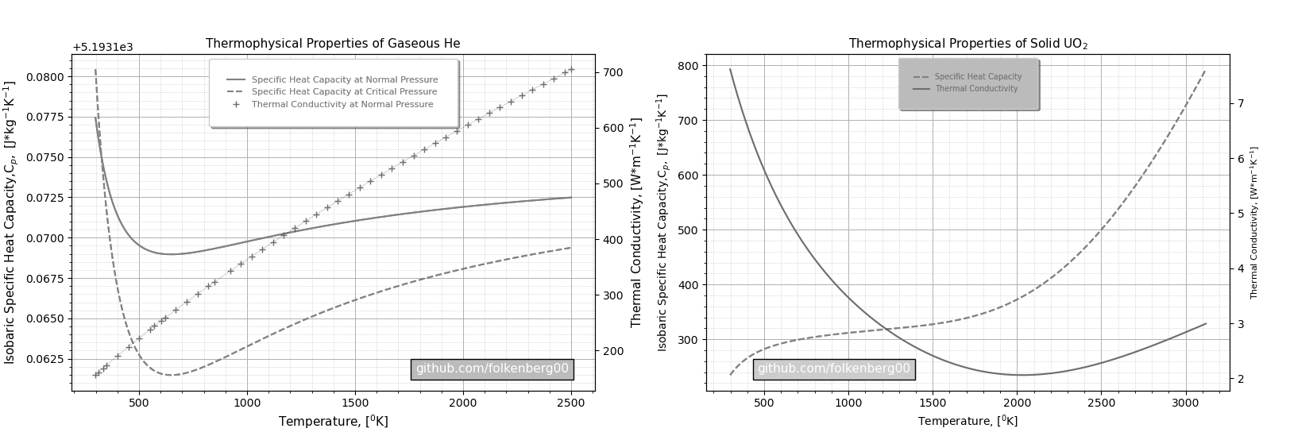**Fig. 2.** Thermophysical properties of the gas gap and the fuel materials

Secondly, we adopt the preliminary design parameters associated with the pin cell in the creation of a CAD model from which geometry data for mesh generation in the computational fluid dynamics (CFD) analysis is retrieved. Thirdly, we prepare schemes for analytical and numerical solutions of the steady-state version of the thermal conduction equation 1. The numerical solution is to be performed in ANSYS. And lastly, the results of the two techniques are to be cross-validated, uncertainty quantification done and presented in the form of peak centerline temperature, fuel and clad temperature distributions, and thermal flux distributions along the radial profile of the reactor core pin cell. This research work can further be extended to take into account thermal hydraulic processes and system behaviour in transient states.

**Literature**

1. Todreas, Neil E., and Mujid S.K. Nuclear Systems I: Thermal Hydraulic Fundamentals. -Hemisphere Pub, 2001.

2. Çengel Yunus A. Heat and Mass Transfer: Fundamentals and Applications. New York, McGraw Hill Higher Education, 2011.

3. International Atomic Energy Agency, Thermophysical Properties of Materials for Nuclear Engineering: A tutorial and Collection of Data. Vienna: International Atomic Energy Agency, 2008.