Smart membrane with electrochemically controlled ion exchange
Nikitina A.A.¹, Skorb E.V.¹, Andreeva D.V. ²
Аспирант, 2 курс
¹ Infochemistry Scientific Center of ITMO University, ITMO University, St. Petersburg, Russia
²Department of Materials Science and Engineering, National University of Singapore, Singapore, Singapore
E–mail: nikitina@itmo.ru

At present research membrane with new way to control properties were suggested. we reported about graphene-oxide based composite (GO-PA) that can selectivity pass through potassium cations and presence of K⁺ allows penetrating Cs⁺ well. The turgor pressure and charge density are driving force, instead well-known pore size. Here we proposed research of interaction GO-PA membrane with cations. Control of ion exchange was done with crystal structure – nickel hexacyanoferrate (NiHCF). It is well-known system [1, 2] for study intercalation cations with electrochemical behavior.
The following electrochemical experiment was done. NiHCF was deposited separately from two types of electrolytes: KNO₃ and LiNO₃. Cyclic voltammetry’s measurements were shown different behavior of lithium and potassium due to different Gibbs energy of the systems [3]. Experiments were done with GO-PA membrane also. In the case of membrane, lithium cations had swelled that is allowed to potassium cations intercalated to the lattice structure.
These results constitute the GO-PA were used as sponge lithium cations and as capacitor. Furthermore, the changing of charge density corresponded to diffusion of cations to the lattice structure or accumulation of the cations on the ridge of NiHCF.

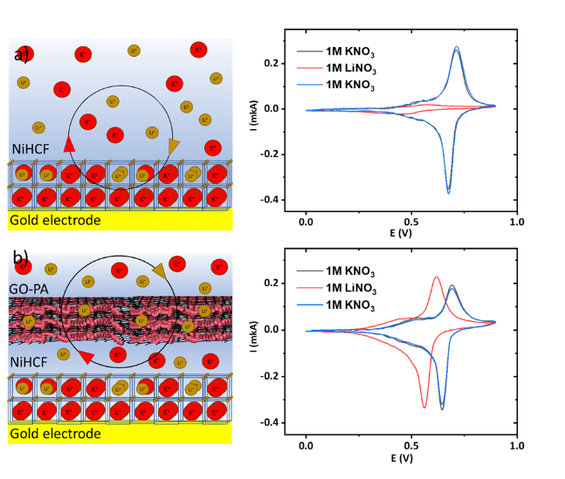
Fig. 1 Schematic illustration and CV measurements and of intercalation process for crystal lattice of NiHCF has been deposited from 1M KNO₃ without membrane (a) and with GO-PA membrane (b).
References

1. Ciabocco, M., Berrettoni, M., Zamponi, S., Spinosi, R., Conti, P. An Overview on the Facile and Reversible Cations Intercalation in Nickel-Hexacyanoferrate Open Framework // International Journal of Electrochemical Science. 2018, №13, p. 5535-5551.
2. Lee, H.-W., Pasta, M., Wang, R.Y., Ruffo, R., Cui, Yi. Effect of the alkali insertion ion on the
electrochemical properties of nickel hexacyanoferrate electrodes // Faraday Discussions. 2014, №176, p. 69-81.
3. Scholz, F., Dostal, A. The Formal Potential of Solid Metal Hexacyanometalates // Angwe. Chem. Int. Ed. 1995, №23(34), p. 2685-2687.

