Theoretical study of structure and tautomeric behaviour of ABABAB-type macroheterocyclic molecule.
Eroshin A.V.
Student, 1 year master
Ivanovo state university of chemistry and technology, Ivanovo, Russia
E–mail: Alexey.Yeroshin@yandex.ru
Investigations of the molecular structure and tautomeric behavior of macroheterocyclic systems have been the subject of the many recent studies. Commonly used DFT calculations often allow to establish the most energetically favorable tautomer and then the preference is discussed in light of fundamental concepts of chemistry. We have studied the structure and conformational composition of the macroheterocyclic ABABAB-type compound 32H,34H,36H-7,8,17,18,27,28-hexa(4-tert-butylphenyl)-trithiaheptacyclo[27,2,1^{1,4},1^{6,9},1^{11,14},1^{16,19},1^{21,24},1^{26,29}]-hexatriaconten (C₇₈N₁₅H₈₁S₃) by DFT calculations (B3LYP hybrid functional with dgdzvp basis set). We have found that, there are two main conformers with C₃ (I) and C₁ (II) symmetry (Fig 1). Atoms forming the central cavity don’t lie in the same plane. In the conformer II two 4-tert-butylphenyl fragments of one pyrrol ring are turned in one direction, and the remaining 4 ones in the other. The conformer of C₃ symmetry have a slightly lower energy (0.06 kcal/mol) than conformer II.

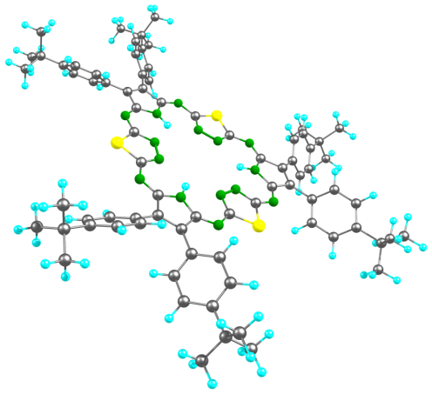 | 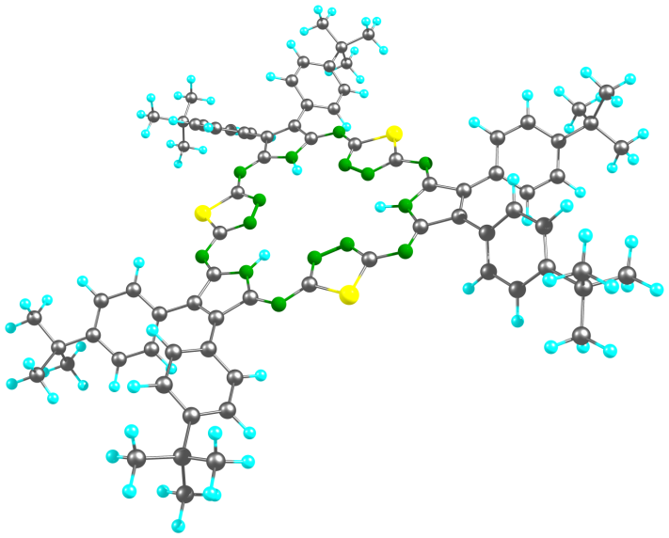
I | II
Fig. 1. The structure of conformers I and II.

This work was supported by grant of the President of the Russian Federation (project MK- -586.2020.3).

