Silver halides crystallization at the aqueous solution-gaseous reagent interface
Strykanova V. V.
Student, 4th year of undergraduate
Saint-Petersburg State University, Institute of chemistry, Saint-Petersburg, Russia
E–mail: vera.stryka@gmail.com
Silver halides exhibit semiconductor and ion-conducting properties [1] and are applied in medicine and catalysis [2], as well as in optical devices, where their ability to reversibly convert to metallic silver under the influence of light is used. Therefore, the development of new ways of their inexpensive and simple synthesis has not lost its significance nowadays.
In the present work, silver (I) chloride (bromide) crystals were obtained as a result of a chemical reaction at the interface between an aqueous solution of AgNO₃ and gaseous HCl (HBr) by Gas-Solution Interface Technique (GSIT) [3]. During the synthesis, a freestanding film was formed on the surface of the solution, after washing the film was transferred to the surface of single-crystal silicon and studied by IR- and Raman spectroscopy, optical and scanning electron microscopy (SEM), microanalysis and X-ray diffraction. We studied the influence of reagent concentrations, pH of salt solutions, duration of treatments on the morphology of the films and the kinetics of their formation. It was established that the reaction product is not a continuous film, but a network formed of nanoparticles 100-500 nm in size for silver chloride (Fig. 1.a) and up to 100 nm for silver bromide (Fig. 1.b). According to X-ray phase analysis, in both cases, the product has a cubic crystal lattice (Fm3m) with parameters specific for the corresponding salts.
Salts under irradiation of a focused electron beam are transformed into metallic silver with a morphology of spherical nanoparticles up to 20 nm in size. The reduction of synthesized halide networks in hydrazine vapors resulted in 1D microstructures of metallic silver on the silicon surface, with the width of about 10 μm.
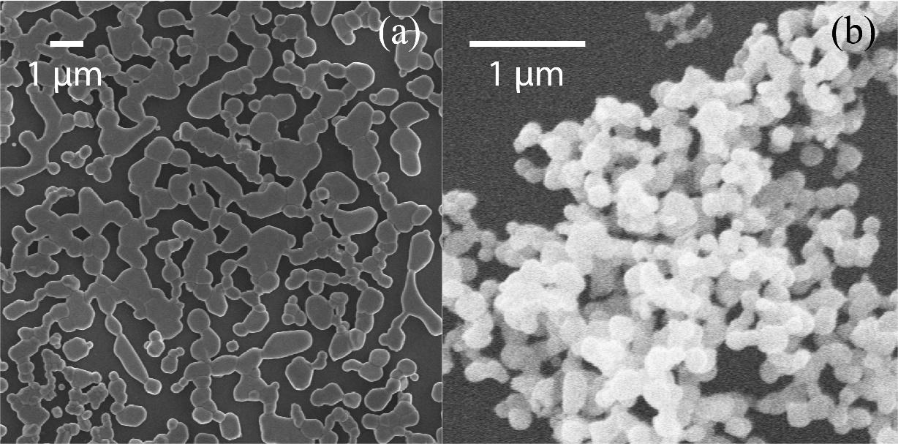
Fig. 1. SEM images of silver halide networks: AgCl was synthesized on the surface of 0.04 M solution within 1 min of processing (a) and AgBr was synthesized on the surface of 0.02 M solution for 22 hours (b).
Author is grateful to the Russian Science Foundation for the support (Grant RSF No. 16-13-10223-P).
References
1. Glaus, S. Calzaferri, G. The band structures of the silver halides AgF, AgCl, and AgBr: A comparative study // Photochemical and Photobiological Science. 2003, №2, p. 398–401.
2. Calzaferri, G. At the time he made the first photographs on paper: Did Henry Fox Talbot oxidize water to oxygen with sunlight? // Catalysis Today. 1997, №39, p. 145-157.
3. Tolstoy, V. P. Gulina, L. B. Synthesis of birnessite structure layers at the solution-air interface and the formation of microtubules from them // Langmuir. 2014, №30(28), p. 8366-8372.

