Synthesis of gold nanoparticles via citrate reduction
Amanmadov A.G.,¹ Kotyrov M.D.²
Student, 5th year of radiophysics and electronics
¹Magtymguly Turkmen State University,
physics department, Ashgabat, Turkmenistan
²Magtymguly Turkmen State University,
Ashgabat, Turkmenistan
E–mail: a.amanmadov@gmail.com
Gold nanoparticles have attracted extensive attention due to their applications in various fields, such as medicine, biotechnology, catalysis, and nanoscale electronics, and are thus the most intensively studied nanoparticles [1-3]. In this work, colloidal gold nanoparticles (CGNPs) were synthesized by the chemical reduction of an acid solution of tetrachloroauric acid (HAuCl₄) as a precursor with a base solution of sodium citrate (Na₃C₆H₅O₇) as a reducing agent at 80-100⁰C. In the literature, this method is known as the Turkevich method [4]. Four different sets of experimental conditions for synthesized colloidal gold nanoparticles are shown in the table 1 [5].
Table 1. Synthesis of colloidal gold nanoparticles
Concentration and volume of reducing agent | Concentration and volume of precursor | Temperature | Particle size (radius)
C=38.8mM, V=2mL | C=1mM, V=20mL | 80⁰C | 64.18nm
C=38.8mM, V=2mL | C=1mM, V=20mL | 100⁰C | 61.15nm
C=38.8mM, V=3mL | C=0.3mM, V=100mL | 100⁰C | 18.34nm
C=38.8mM, V=30mL | C=0.5mM, V=300mL | 100⁰C | 15.27nm
UV-Vis spectrometry and Dynamic Light Scattering (DLS) were used to obtain the absorption spectra and the hydrodynamic radii of the synthesized CGNPs with their size distribution. UV-Vis absorption spectra were recorded from 400nm to 900nm using a СФ-2000 Спектрофотометр. The particle size was measured using a Photocor mini equipped with a 25 mW temperature stabilized diode laser (654nm) and operating at an angle of 90⁰ and a temperature 18-22⁰C.The DLS intensity size distribution and absorption spectrum of synthesized CGNPs are shown in Figure 1 and Figure 2.
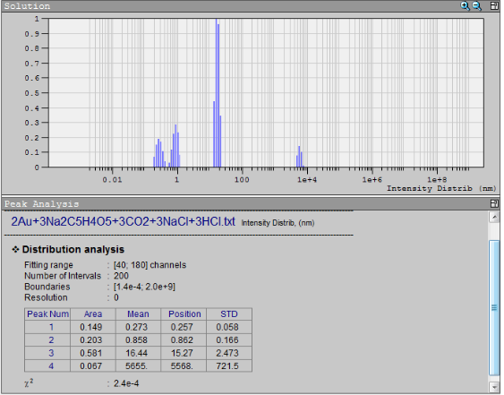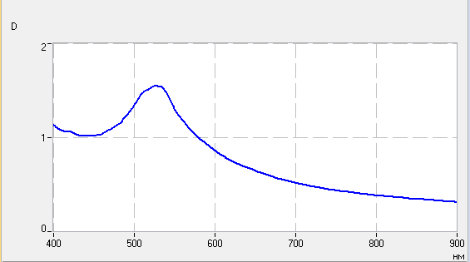
Figure 1. DLS intensity % vs. size graph Figure 2. Absorption spectra of 15.27 nm CGNPs
We have showed that at the 7:1 citrate-to-gold molar ratio the final size can be reduced to 15nm without losing the stability.
References
1. Agunloye, E., et al. A model for the formation of gold nanoparticles in the citrate synthesis method. Chem. Eng. Sci. 2018. https://doi.org/10.1016/j.ces.2018.06.046
2. Wuithschick, M.,et al. Turkevich in new robes:key questions answered for the most common gold nanoparticle synthesis. Phys. Chem. 2015. https://doi.org/10.1021/acsnano.5b01579
3. Ji, X.H., Song, X.N., Li, J., et al. Size control of gold nanocrystals in citrate reduction: the third role of citrate. J. Am. Chem. Soc. 129, 13939. 2007
4. Turkevich, J., Stevenson, P. C., Hillier, J. Discuss. Faraday Soc. 11 55. 1951
5. Amanmadov, A., et al. Synthesis of gold nanoparticles via citrate reduction and their characterization. ЕСУ 12/69. 2019. https://doi.org/10.1618/ESU.2413-9335.2019.3.69.492

