Self-healing materials based on polymer-metal complexes of nickel(II) and pyridinedicarboxamide-co-polydimethylsiloxanes
Deriabin K.V., Islamova R.M.
PhD student, fourth-year student
Saint Petersburg State University,
Institute of Chemistry, Saint Petersburg, Russia
E–mail: deriabin.k@yahoo.com
Obtaining new self-healing polysiloxanes is one of the most urgent tasks for modern chemistry. It helps in increasing the shelf life of materials, reducing the costs of maintaining them, as well as improving their safety. Self-healing polysiloxanes are extensively used for flexible sensors, second skins [1], additive technology [2], and self-healing coatings [3].
Nickel(II)-pyridinedicarboxamide-co-polydimethylsiloxanes (Ni-Py-PDMSs) are novel air-stable self-healing silicone materials. In the course of our research Ni-Py-PDMSs were obtained by the complexation between nickel(II) chloride and pyridinedicarboxamide-co-polydimethylsiloxanes (Py-PDMSs with a different PDMS unit length M_{n}: = 850–900, 5000 or 25000 g∙mol⁻¹). In order to analyze the structure of Ni-Py-PDMSs, a low-molecular weight model nickel(II) complex was obtained using 2,6-butylpyridinedicarboxamide and NiCl₂∙6H₂O. It was characterized by X-ray crystallography and mass-spectroscopy, proving that the Ni²⁺ ions form complexes via the Ni–N_{Py} and Ni–O coordination. According to UV and IR data of Ni-Py-PDMSs and the model complex, both homoleptic and heteroleptic complexes with Ni²⁺, Py-PDMSs and a solvent exist in the Ni-Py-PDMSs. An equilibrium has been established between the homoleptic and heteroleptic complexes (Fig. 1) that provides self-healing of the Ni-Py-PDMSs.
Elasticity of Ni-Py-PDMSs change by controlling metal content, and by the PDMS chain length. Ni-Py-PDMSs combine relatively high mechanical firmness (Young’s modulus is up to 1.75 MPa) and elastic properties (up to 1800%), with low hysteresis (down to 3%). Ni-Py-PDMSs exhibit excellent autonomous self-healing performance. Thus, the self-healing efficiency of Ni-Py-PDMSs gets to 92.5% at room temperature.
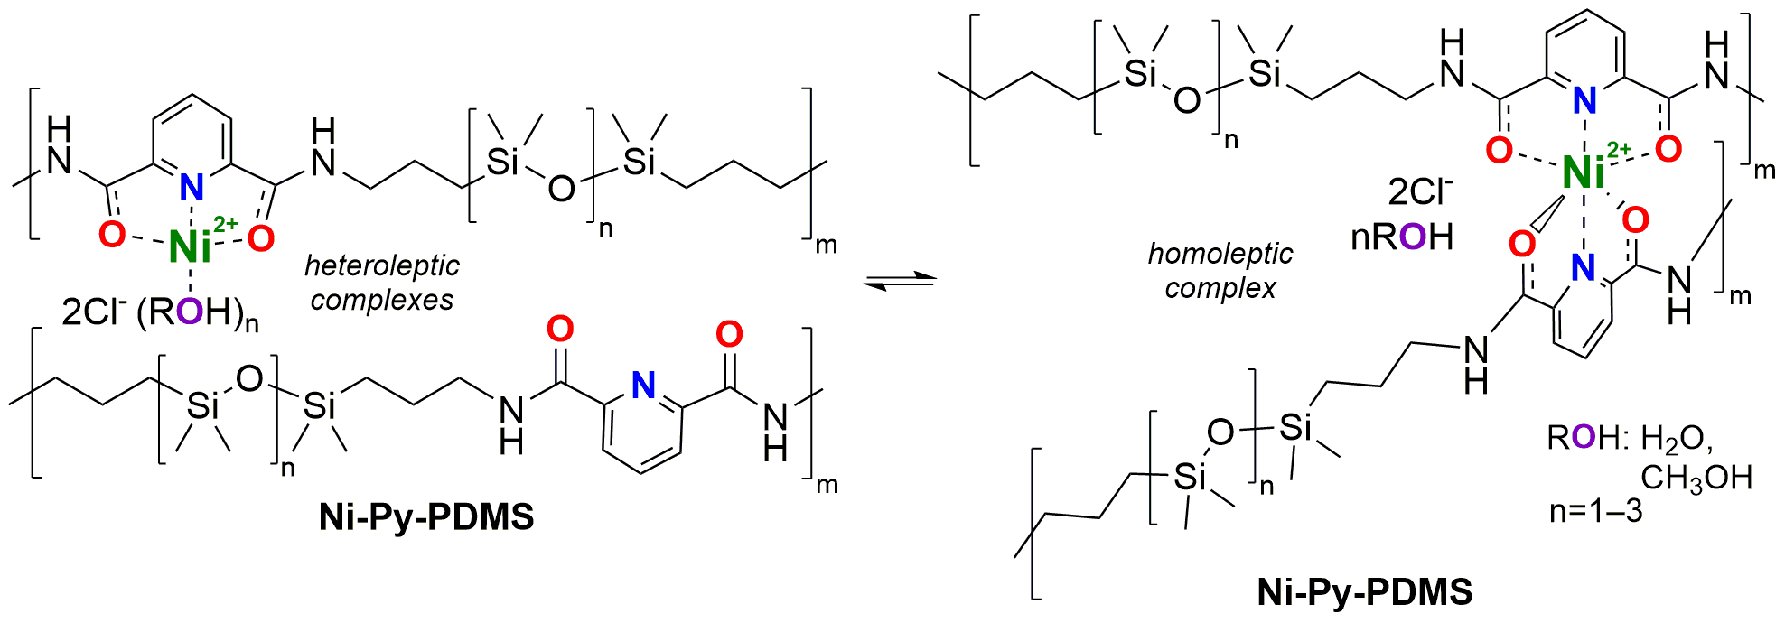
Fig. 1. Reversible ligation in the Ni-Py-PDMSs.
Acknowledgments. The synthesis and assessment of mechanical and self-healing properties of Ni-Py-PDMSs were financially supported by RFBR (project № 19-33-90134). The measurements were performed at the Chemical Analysis and Materials Research Centre, Centre for X-ray Diffraction Studies, and Centre for Innovative Technologies of Composite Nanomaterials (all in SPbU).
References
1. Wang S., Oh J.Y., Xu J., Tran h., Bao Z. Skin-Inspired Electronics: An Emerging Paradigm // Acc. Chem. Res. 2018, №51(5), p. 1033–1045.
2. Yu K., Xin A., Du H., Li Y., Wang Q. Additive manufacturing of self-healing elastomers // NPG Asia Mater. Springer US. 2019, № 11(1), p. 1–11.
3. Zhuo Y., Håkonsen V., He Z., Xiao S., He J., Zhang Z. Enhancing the Mechanical Durability of Icephobic Surfaces by Introducing Autonomous Self-Healing Function // ACS Appl. Mater. Interfaces. 2018. Vol. 10, № 14. P. 11972–11978.

