Synthesis of glycosilicone based on propargylated hydroxyethyl cellulose and azidated polydimethylsiloxane via CuAAC
Dobrynin M.V.
PhD student, 4 year
Saint-Petersburg State University,
Institute of Chemistry, Saint Petersburg
E–mail: mdobrynin42@yandex.ru
Glycosilicones are hybrid structures consisting of saccharide and (poly)siloxane fragments. Due to unusual structure, these compounds are of interest for both biomedicine and microfluidics (as surface modifiers). The most complicated problem of glycosilicones is synthesis [1]: polysiloxanes are hydrophobic and saccharides are hydrophilic; no solvent dissolve both reagents. Therefore, there is necessity in developing methods utilizing effective reactions such as CuAAC.
In current work methods for synthesis of glycosilicones from polydimethylsiloxane and hydroxyethyl cellulose via CuAAC was developed. Azidated polydimethylsiloxane reacted with propargylated hydroxyethyl cellulose in the presence of CuSO₄×5H₂O as catalyst. In contrast with published method [2], there is less amount of azide groups in product after purification because it is easier to get rid of unreacted polysiloxane than hydroxyethyl cellulose. Therefore, obtained products will be less toxic what is an advantage for medical application. Glycosilicones were successfully synthesized via CuAAC reaction what is confirmed with IR and solid state NMR spectroscopy. They are insoluble in water, but swell in organic solvents. Glycosilicones are less hydrophilic than original hydroxyethyl cellulose: contact angles are 103–123°.
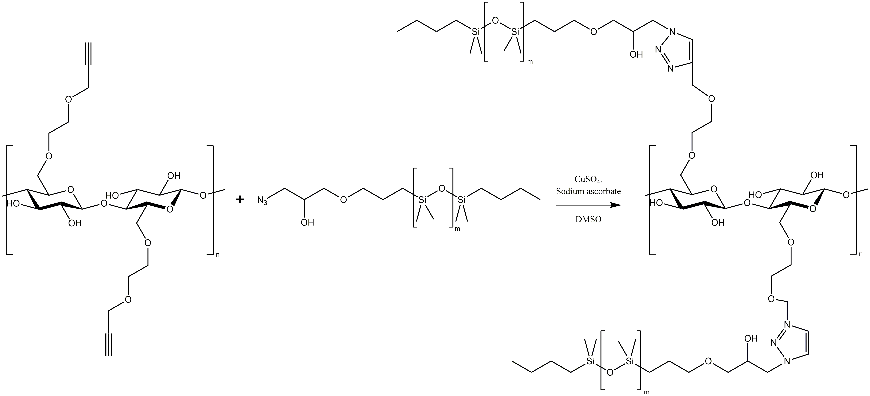
Acknowledgments:
This work was funded by the Russian Foundation for Basic Research (project 19-33-90130). Measurements were performed at Center for Magnetic Resonance, Center for Chemical Analysis and Materials Research, Thermogravimetric and Calorimetric Research Centre, Centre for Culture Collection of Microorganisms, Centre for Innovative Technologies of Composite Nanomaterials.
Literature:
1. S. Boileau, B. Boury and F. Ganachaud, Silicon Based Polymers, Springer Netherlands, Dordrecht, 2008.
2. A. M. Eissa, E. Khosravi and A. L. Cimecioglu, A versatile method for functionalization and grafting of 2-hydroxyethyl cellulose (HEC) via Click chemistry, Carbohydrate Polymers, 2012, №90, p. 859–869.

