Manufacturing of highly porous magnesium-substituted hydroxyapatite bioceramics
via gel-casting
Shymanskaya H.N.¹, Podsosonnaya A.D.²
Lecturer, PhD¹
^{1,2}Belarusian State Technological University, Chemical Technology and Engineering Faculty, Minsk, Republic of Belarus
E-mail: shimanskaya@belstu.by
The aim of this work is to development of compositions and technological parameters for the production of magnesium-substituted hydroxyapatite bioceramics by gel-casting, to establish the relationship between physicochemical properties of the synthesized materials, their structure and composition of initial mixture. In this study, agar-agar was used as gelling agent.
The synthesis of magnesium-substituted hydroxyapatite was conducted using calcium nitrate tetrahydrate Ca(NO₃)₂·4H₂O (chemically pure grade, GOST 4142); magnesium nitrate hexahydrate Mg(NO₃)₂∙6Н₂О (analytical grade, GOST 11088); ammonium hydrogen phosphate (NH₄)₂HPO₄ (grade A, GOST 8515); ammonium hydroxide NH₄OH (25 % NH₃ in H₂O, ultrapure grade, GOST 24147) and distilled water according to the following equation:
(10–x)Ca(NO₃)₂ + xMg(NO₃)₂ + 6(NH₄)₂HPO₄ + 8NH₄OH → Ca_{(10–x)}Mg_{x}(PO₄)₆(OH)₂ +
+ 20NH₄NO₃ + 6H₂O (0.55 ≤ x ≤ 0.65).
The solution obtained by dissolving Ca (NO₃)₂·4H₂O and Mg(NO₃)₂∙6Н₂О in a beaker was added dropwise into a solution of (NH₄)₂HPO₄ with constant stirring. By adding NH₄OH, the pH of the solution was kept constant at 7–7.5 throughout the synthesis process. The synthesis was carried out at 60 ºC. The precipitate and the mother liquor were cooled down to room temperature and left for 7 days. The resulting precipitate was separated by filtration, washed with distilled water and dried at 80 ºC. Particle size of obtained powder was between 5–10 μm (Analysette 22, Germany), X-ray phase analysis (diffractometer DRON-2, Russia) indicated hydroxyapatite Ca₁₀(PO₄)₆(OH)₂ (ICCD file 9-432) and 2Сa₃(PO₄)₂·CaMg₂(PO₄)₂ (ICCD file 20–348).
Prepared agar-agar solutions were mixed with hydroxyapatite at 60 °C. Ratio of magnesium-substituted hydroxyapatite/agar-agar was 17.1:1. The fluidity of the suspensions ranged between 15 and 16 s. The samples were prepared by gel-casting in plastic molds. After freezing, they were removed from the molds, dried at 80 °C, and fired at 1100, 1150 and 1200 °С.
The physical and chemical properties of the bioceramics sintering at 1100–1200 °С were the following: water absorption – 24.8–114.7 %, apparent porosity – 38.5–76.7 %, bulk density – 677–1643 kg/m³, compressive strength – 0.2–3.0 MPa.
XRD study revealed that crystalline phases were represented by hydroxyapatite, 2Сa₃(PO₄)₂·CaMg₂(PO₄)₂ and tricalcium phosphate β-Ca₃(PO₄)₂ (ICCD file 9–169). The pore size was approximately 2–150 μm (Figure).
× 1000 × 2000
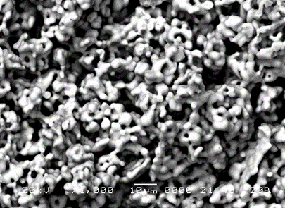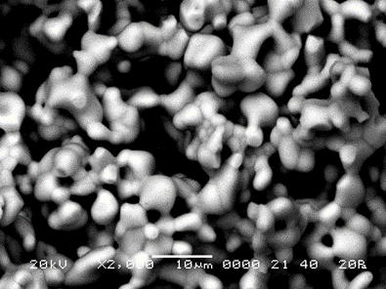
Figure – SEM micrographs of magnesium-substituted hydroxyapatite bioceramics
The obtained porous material seem to be a promising bone substitution material.

