Comparison of attraction errors across number and person categories
Korotkaya Maya Borisovna
Student of HSE, Moscow, Russia

The object of present study are attraction errors in person and number in a particular stimuli configuration described below. The most prototypical attraction error is shown in the example:
- The key to the cabinets are rusty.
In (1) the verb “are” agrees not with the head of the subject DP “the key”, but with an intervening DP “the cabinets” – an attractor. Initially it was thought that this occurs because of linear proximity. Nevertheless very soon scientists realized that syntactic structure is more important.
Experimental studies on attraction errors show that the size of this effect differs depending on. For example, plural attractors cause stronger attraction effect than singular attractors. Greater markedness and lower frequency of plural number are believed to be the cause. This pattern is referred to as the plural markedness effect.
However, recent studies showed that person acts contrary to markedness-frequency theory: 1st, 2nd and 3rd persons cause equal attraction effects (while it should be 1st and 2nd > 3rd). We aimed to test whether equal attraction in person is caused by the particular stimuli configuration. We decided to compare the sizes of attractions effect across number and person categories – if the specific configuration of our stimuli make any attraction effects for person vanish, it also will work for number. Actually our configuration differs from a “classical” configuration (1): in (1) “to the cabinets” relates only to the subject DP while in our configuration attractor modifies the whole sentence.
We ran an online self-paced reading study (N=79) with 60 stimuli (20 with 1sg attractor, 20 with 3sg attractor, and 20 with 3pl attractor) in a 2x2 design: we crossed sentence grammaticality with attraction (verb matching/mismatching the attractor pronoun). The interaction between these effects would speak in favor of agreement attraction.
- Drujishe, ja, kak i (ty / on), ot gloopyh konkursov (ustayu/ustayot) kajduyu svadbu.
Friend, I, just as (you / he), of stupid contests (am/is) tired every wedding.
“Just as you, I am tired of stupid contests every wedding”.
However, in the analysis of reading times (mixed-effects linear modeling performed in R was used) we found only the slowdown in ungrammatical sentences in all configurations, but no interaction between the main effects. No attraction effect neither in person nor in number.

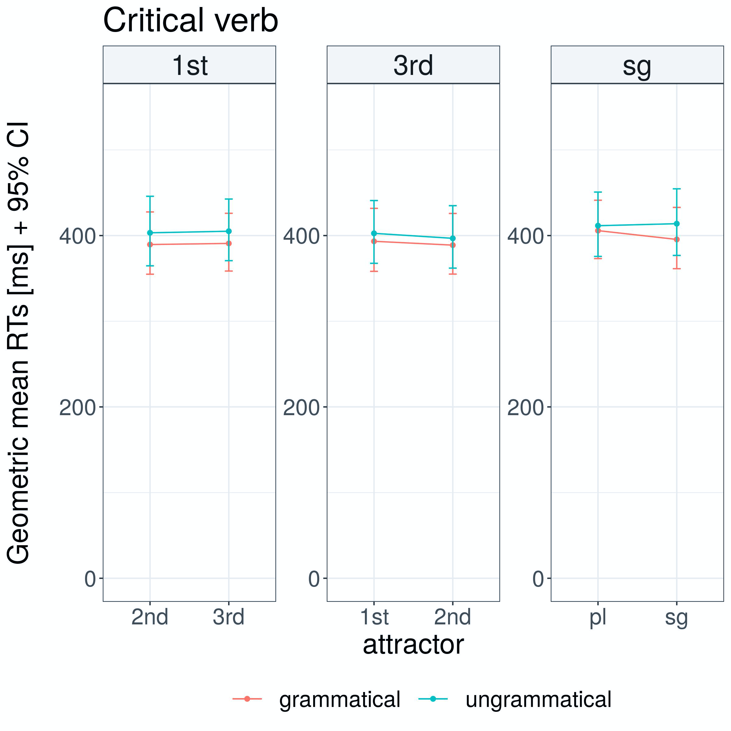

This might be the result of the particular stimuli configuration, relatively high (22%) proportion of ungrammatical sentences in the experiment, or of altogether smaller attraction effects in Russian.
References
Bock, K., Miller, C. A. Broken agreement // Cognitive Psychology. Vol. 23. 1991. P. 45–93.
Eberhard, K. M., Cutting, J. C., Bock, K. Making syntax of sense: Number agreement in sentence production // Psychological Review. Vol. 112. 2005. P. 531–559.
Laurinavichyute, A., Simdianova, A., Vasishth S. Agreement attraction in
person: comprehension in Russian Proceedings of the 30th Annual CUNY Conference on Human Sentence Processing, Boston, MA, USA, 2017. Massachusetts Institute of Technology.
Slioussar, N., Malko, A. Gender agreement attraction in Russian: production and comprehension evidence // To appear in: Frontiers in Psychology. 2016.

