Quantitative methods of describing an idiolect
Krasin Artem Aleksandrovitch
Master student, 2nd year, Lomonosov Moscow State University, Moscow, Russia

According to the Stanford Encyclopedia of Philosophy, the idiolect “is a language the linguistic (i.e. syntactic, phonological, referential, etc.) properties of which can be exhaustively specified in terms of the intrinsic properties of some single individual, the person whose idiolect it is” [Barber: 3]. We refer idiolect to discourse understood as a form of language being, as “speech immersed in real life”.
We view discourse as the most natural way of expressing the unity of oral and written speech. As L.L. Baranova notes in her monograph “The ontology of English writing”, “both these forms throughout the evolution of a language exist in the complicated dialectical interconnection and mutually affect each other. We cannot truly understand the role, place, and use of the one without relating and comparing it to the other. It is, in principle, impossible” (my translation) [Baranova 2008: 2]. Aleksandrova O.V. supports these conclusions in her article “The plurality of speech and its discursive characteristics” saying that “discourse is a dynamic process reflecting functional features of speech, but at the same time it has all the characteristics of its pragmatic, expressive and cognitive features” (my translation) [Aleksandrova 2007: 1].
It is reasonable to maintain that a variety of methods used in discourse analysis should be applied in studying idiolect. We hypothesize that the material of diaries is one of the written forms that are most suitable and representative for analyzing discourse and idiolect, even retrospectively. Charles Belgrave’s diaries were the main object of research. Charles Belgrave served as an advisor for Bahraini hakims and also was an agent of British colonial policy. He left a prominent written legacy including diaries covering the period from 1926 to 1947.
A huge variety of problems in linguistics and literary studies needed a method that could help attribute, compare, and contrast different texts. A discipline concerning such problems as author profiling and style comparison took the name of stylometry. A number of works in this sphere was written by Russian and international linguists, philosophers, and mathematicians, e.g. Wincenty Lutoslavsky, Anna Wierzbicka, Carlo Ginzburg, Suzanne Romaine, G.Y. Martynenko, A.V. Zenkov and others. The most successful solution came only in 2002 when John Burrows proposed a new measure of stylistic difference called Delta. In his article “ ‘Delta’: a Measure of Stylistic Difference and a Guide to Likely Authorship” he writes: “I sketched a new way of using the relative frequencies of the very common words for comparing written texts and testing their likely authorship” [Burrows 2002: 4].
The hypothesis is that the diaries are stylistically distant from autobiographies that may have the same subject and even specific words, but their language is already refined and regularized comparing to the idiolect of personal diaries. To prove the point we have compared the diaries with autobiographies using the “stylo” – a set of stylometric tools for the statistical programming language R – and particularly the method of cluster analysis.
The mentioned uniqueness of the material made finding texts for comparison a challenging task. Texts that we look for should be 1) non-fictional 2) written in the same period of time 3) written by a male author 4) preferably describing administrative or military service in British colonies or puppet states 5) for the sake of comparison they might be slightly edited by their authors.
For comparison the following works have been chosen: “The Seven Pillars of Wisdom: A Triumph” by T.E. Lawrence, “My Early Life” by W. Churchill. These texts met all the mentioned-above requirements.
For the experiment, we took the fragments from “The Seven Pillars of Wisdom: A Triumph” by T.E. Lawrence, “My Early Life” by W. Churchill, and C. Belgrave’s diaries 1926-1928.
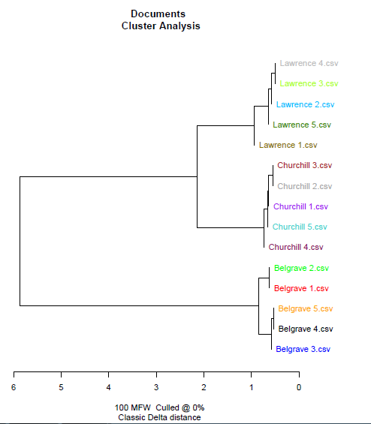
Figure 1
The experiment has provided interesting results for proving the hypothesis. Using the method of agglomerative cluster analysis the samples were merged step by step in larger groups. As might be seen in Figure 1 after bringing together the samples of one author the program consequently merged Lawrence’s and Churchill’s texts, while the height of the branch connecting the new merged cluster with the cluster of Belgrave’s texts demonstrates its stylistic independence. The data gained from the cluster analysis serves to find a resemblance between stylistically different texts and at this stage, this proves our main hypothesis – Belgrave’s diaries constitute a unique material distinct from its contemporary non-fictional autobiographies.
References
- Aleksandrova O.V. The diversity of speech and its discursive characteristics // Problems of Cognitive Lingustics. 2007. №4. URL: https://cyberleninka.ru/article/n/mnogoobrazie-rechi-i-ee-diskursivnye-harakteristiki. - p.38
- Baranova L.L. The ontology of English writing. A teaching guide to the course of lectures on orthoepy and orthography of modern English. 2nd ed. /L.L. Baranova – M.: Publishing house of PSTGU, 2008. – p.11
- Barber, Alex and Ramirez, Eduardo Garcia, "Idiolects", The Stanford Encyclopedia of Philosophy (Spring 2017 Edition), Edward N. Zalta (ed.), URL: https://plato.stanford.edu/archives/spr2017/entries/idiolects
- Burrows John, ‘Delta’: a Measure of Stylistic Difference and a Guide to Likely Authorship, Literary and Linguistic Computing, Volume 17, Issue 3, September 2002, Pages 267–287, URL: https://doi.org/10.1093/llc/17.3.267

