A common ground of mutual cluster management and its sustainability
Tursunov Aibek Ravshanbekovich
PhD student
National Research University High School of Economics
E-mail: atursunov@hse.ru

Active discussion on the topic of formation inter-regional clusters and cooperation in cluster policies framework between countries for Russia considers study fields on mutual values and interests’ intersections. Whereas, formation and assistance in developing cluster initiatives within the framework of the Shanghai Cooperation Organization (SCO), Asia-Pacific Economic Cooperation (APEC) and the Eurasian Economic Union (EAEU) topic conceptualization has begun. Respectively to the world experience, that shows possible long-term interaction between clusters and mutual management, which is based on the common values creation for sustainable development of such collaboration. This article discusses factors that could tie clusters in the long run. Creating interest intersections and common development goals between clusters, implying sustainability. Giving a special focus in the formation and management of the aforementioned sustainability. By examining in cluster management sustainable indicators and modeling them to form mutual goals.
Cluster competitiveness [1], globalization [2] and internationalization of innovation [3] are factors in formation of integration [4], interconnection networks and collaboration between clusters. In other words, there are needs for intensive interaction and cooperation between clusters [5]. For example, with such approach were developed the European Cluster Collaboration Platform (ECCP), which integrates clusters in the EU and worldwide, being international cluster cooperation and collaboration center. On the one side, leading clusters through networks putting effort in globalization and inclusion of their products in the global value chains [6], on other side, developing country cluster initiatives concerned as growth points and drivers [7] of specific industry development.
The EAEU is a potential economic union for industrial complexes, which facilitates comparative advantages and increases in scale, not only in production capacity, but also in expanding the market, lengthening the products value chain, thereby, benefiting from the already constructed economic zone. Forming the concept and functional collaboration model across the EAEU introduced in the clustering models development and the interconnected digitalization of high-tech industries in the EAEU by V.Avilova et al. [8]. As the presented model considers a centralized technology platform for interaction and cluster management, consequently, cluster organizations as governing structures should oversee clusters and promote the use of the platform. Managing a certain sustainable development of the collaboration. As we know, clusters are geographically linked and managed/supervised by a specialized cluster organization, which within the framework of its responsibilities and capabilities, could require implementation of installations and creation of various projects, allowing us to consider cluster organizations as integral structures between different clusters in the EAEU. At the same time, they consolidate funding and government support for clusters and their participants. As we have already decided on the inclusion of sustainable development in the general framework of interaction, guided by the management principles and functions, choosing sustainable development standardized indicators we manage approaches coherence (Figure 1) for the cluster members and clusters themselves in the EAEU zone. From what following the sustainable development management between clusters at the level of:
- cluster development centers;
- ministries and regional authorities;
- intercountry level.
Summarizing the overall picture of sustainable development at various levels for cluster development and for its participants, new initiatives are opened to support various projects that increase the socio-economic importance for the entire economic union. In other words, sustainable development management exactly takes place as the sustainable development goals achievement (SDGs) control and monitoring. Considering, the rooting of sustainable development awareness and the reporting requirement for each level will allow clusters and members to work on the economic union socio-economic challenges, in order to receive state support and grants.

Figure 1 Sustainability indicators in mutual cluster management
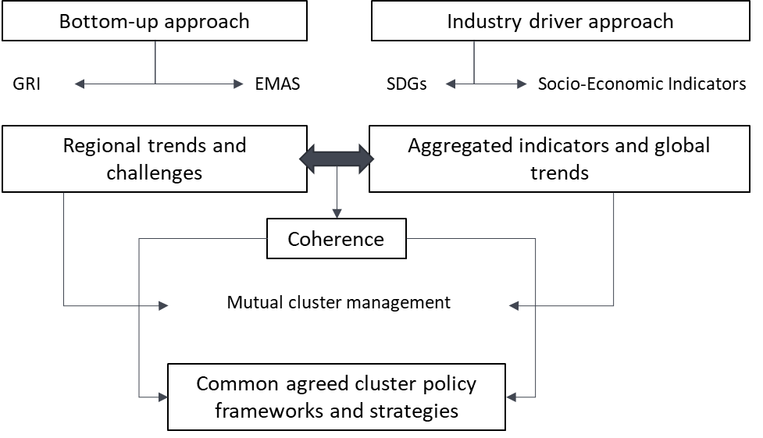

Figure 2 Cluster collaboration sustainability management system
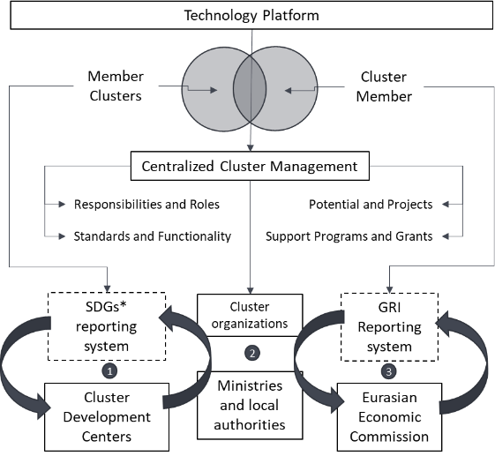

Cluster organizations, as key players connecting and consolidating sustainable development (Figure 2), have huge management advantages. But at the same time, the creation of technological platforms for sustainable relations between clusters and individual approach in sustainable development indicators selection, within the common interests` framework of the economic union, is required. Cluster organizations as a connecting link between participants and cluster organizations should not limit their member to create sustainability initiatives, as they can become a source for the next cooperation and collaboration between clusters.

References
- Cappellin R. & Wink R., International knowledge and innovation networks: Knowledge creation and innovation in medium technology clusters. Edward Elgar Publishing, 2009.
- Porter M. E., Location, competition, and economic development: Local clusters in a global economy. Economic development quarterly, 2000, 14(1), р. 15-34.
- Islankina E.А., (2015). Internationalization of regional clusters: theoretical and empirical issues. Higher School of Economics Research Paper No.WP BRP, 2015, р. 41.
- Popkova E. G., Sukhova V. E., Rogachev A. F., Tyurina Y. G., Boris O. A. & Parakhina V. N. (Eds.), Integration and clustering for sustainable economic growth. Springer International Publishing, 2017.
- Asheim B. T. & Isaksen A., Regional innovation systems: the integration of local ‘sticky’and global ‘ubiquitous’ knowledge. The Journal of Technology Transfer, 27(1), 2002, р. 77-86.
- Ketels C. H. & Memedovic, O., From clusters to cluster-based economic development. International journal of technological learning, innovation and development, 1(3), 2008, р. 375-392.
- Иванова Л. Н. и Терская Г. А. Точки роста и драйверы роста: к вопросу о содержании понятий. Journal of institutional studies (Журнал институциональных исследований), 7(2), 2015.
- Avilova V. V., Shaykhutdinova F. N., & Kuramshina K. S., Models of cluster and digital integration of high-tech industries of the Eurasian Economic Union countries. In International Scientific and Practical Conference on Digital Economy (ISCDE 2019). Atlantis Press, 2019.

