Synthesis, morphology and catalysts properties of LaFe_{0.7}Ni_{0.3}O₃ doped Ca
Porokhin S.V.
Skolkovo Institute of Science and Technology, Moscow, Russia
E-mail: Sergei.Porokhin@skoltech.ru

The lanthanum perovskite remains an attractive catalysts material for reliable high-temperature operation in an oxidative atmosphere due to the low processing cost and non-toxicity [1]. Nowadays the element substitution and application the new methods of synthesis are approaches to enhance functional properties of materials. In this study, we report about synthesis, morphology and catalysts properties of Ca doped lanthanum perovskite prepared by spray pyrolysis method.
Samples with the chemical composition La_{1-x}Ca_{x}Fe_{0.7}Ni_{0.3}O₃ (x=0, 0.3, 0.5) were prepared from the solutions of appropriates nitrate mixed in stoichiometric proportion, and solvated in deionized water to obtain 10 mass% solution. The resulting solution was sprayed by ultrasonic generator at 2.64 MHz and carried out in to the reaction zone of the tube furnace at 1350 K in the stream of atmosphere gas. Then powders were annealed with 10 hour in air atmosphere at 800 ºC, the SEM image of undoped sample (x=0) and TEM image of doped sample (x=0.3, zone [210]) shown on fig. 1.

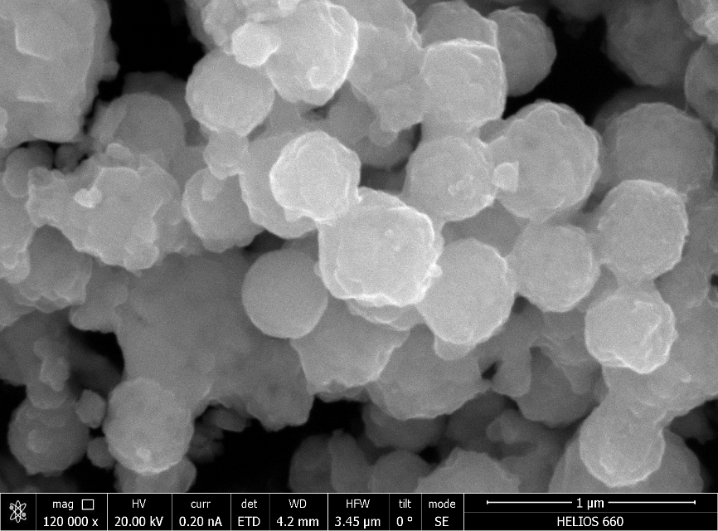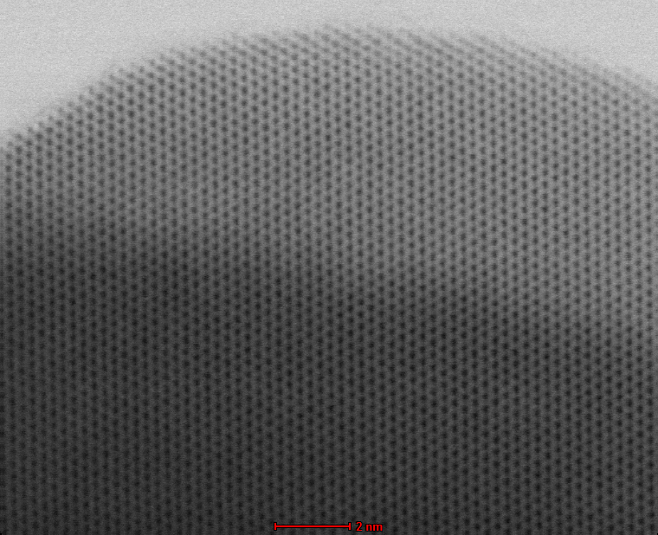
Fig.1 – SEM (left) and TEM (right) images of annealed samples

The resultant powders represented as sphere shape, particle diameters vary from 300 to 1000 nm. Specific surface area was studied on Quantachrome Instruments. Characterization of composition, grain size and structure were performed using scanning, transmission electron microscope and X-ray diffractometer. The activity of oxygen evolution reaction (OER) and oxygen reduction reaction was determined on standard three-electrode cell using a Hg/HgO reference electrode. All electrochemical measurements were carried out in O₂-saturated 1 M NaOH with mass loading = 51 μg/cm² of sample. The Mass activity at RHE=0.693 V of undoped sample (composition: Perovskite/Vulcan Carbon) = 15.4 [A/g] , which is lower in two times than commercially available Pt/С, and at RHE = 1.63 V, mass activity = 9.18 [A/g] which is comparable with IrO₂/Vulcan Carbon.

Reference:
1. Chen D. et al. Nonstoichiometric oxides as low-cost and highly-efficient oxygen reduction/evolution catalysts for low-temperature electrochemical devices //Chemical reviews. – 2015. – Т. 115. – №. 18. – С. 9869-9921.

