Synthesis of carbon nanoporous materials based on oxidized coal
Zhenisova A.K.
Junior Researcher
“Institute of coal chemistry and technology” LLP , Astana, Kazakhstan
E-mail: ms.tanabaeva95@mail.ru

As a result of weathering in reservoir conditions, the organic mass of coal acquires a new set of various oxygen-containing groups, and the presence of such functional groups causes the high reactivity of coals towards the activating agent (for example, KOH), which positively affects the process of chemical activation during carbonization. The advantages of this method are the possibility of using oxidized coals for the production of carbon materials for the purpose of their subsequent use as carriers of catalysts, sorbents and other types of products. Chemical activation with alkali followed by carbonization of oxidized coal leads to the formation of a developed porous structure. This method was used in the present work to obtain carbon nanoporous materials from the oxidized coal “Shoptykol” of the Maikuben basin.
To obtain adsorbents, a portion of crushed coal was soaked with 50% alkali (KOH) solution for 24 hours at a certain coal / alkali ratio of 1: 0.5; 1: 1. Next, the mixture was dried, placed in closed ceramic crucibles and sent to a thermogravimetric analyzer for the carbonization process. Carbonization consisted of two stages: heating to 800° C at a rate of 7-9° C / min and keeping at 800° C for 60 minutes. The cooled adsorbent was washed from alkali residues and dried at 105° C to constant weight. The elemental composition of the carbon material is shown in Table 1. The electron microscopic photograph of the carbon material is shown in Fig. 1, where particles of carbon nanotubes with a diameter from ∼50 to ∼85 nm are clearly visible.

Table 1 -Chemical composition of carbon nanosorbents

Coal/alkali ratio | The content of elements, wt. %
Coal/alkali ratio | C | O | Mg | Ca | Ті
1:1 | 87,75 | 7,59 | 0,58 | 0,91 | 0,52
1:0,5 | 88,94 | 9,03 | 0,20 | 1,15 | 0,68

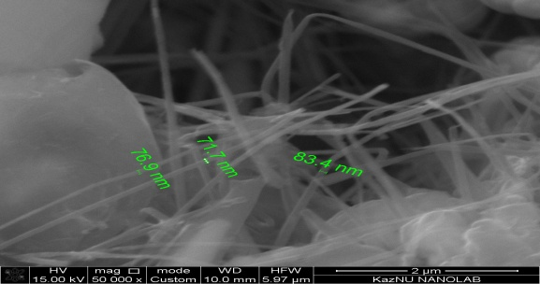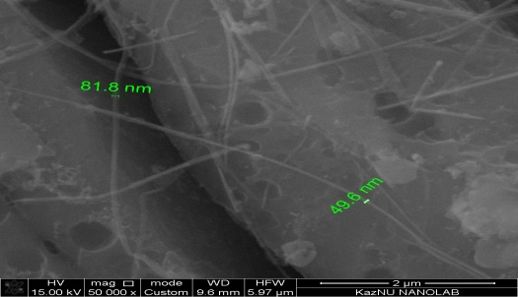
а) б)

Figure 1 - SEM images of coal/alkali: a -1: 1, b -1: 0,5

Thus, as a result of high-temperature carbonization of oxidized coal from the Shoptykol deposit, porous carbon nanomaterials were obtained, with a specific surface area of 1058.146 m²/g, 1046.810 m²/g and a specific pore volume of 0.453 cm³/g, 0.448 cm³/g for a ratio 1: 1 and 1: 0.5 respectively. In this regard, the nanomaterial can be considered promising, in particular, as an adsorbent, superconducting materials, capacitors and fuel cells.

