Synthesis of carbon nanotubes by gas phase deposition method
Kazankapova M.K.
Researcher, PhD
“Institute of coal chemistry and technology” LLP, Astana, Kazakhstan
E-mail: maira_1986@mail.ru

Recently carbon nanotubes due to their unique properties — carbon allotropes with a cylindrical nanostructure — have attracted the greatest interest among nanomaterials [1, 2].
As a result of the high-temperature pyrolysis process at 800° C (in an inert environment), carbon nanotubes (CNTs) were obtained by CVD (Chemical Vapor Deposition) by decomposing carbon monoxide on the surface of the Co-catalyst, where hydrophobic ash of shale from Kendyrlyk deposit was used as a catalyst carrier ( Kazakhstan) based on carbon black. The optimal condition for the production of CNTs by the catalytic method was established, where the exposure time was 120 minutes at a pyrolysis temperature of 800° C. The yield of carbon nanotubes per unit mass of the catalyst was 30%
The elemental composition, structure, and dimensions of the catalyst and CNTs were studied on a Quanta 3D 200i scanning electron microscope with the addition of energy dispersive spectrometry. The samples were measured by the Raman spectroscopy method using a Solver Spectrum (NT-MDT) setup, using a 100x objective and exciting radiation in the visible range from a semiconductor laser λ = 473 nm.
After synthesis, carbon materials in the form of a film formed on the walls of the reactor. The elemental composition of the carbon material showed the presence of 100% pure carbon. An electron microscopic photograph of a fragment of a carbon material containing CNTs is shown in Figure 1, where CNT particles with diameters from ∼90 to ∼230 nm are clearly visible, which are folded into a single, seamless cylinder.

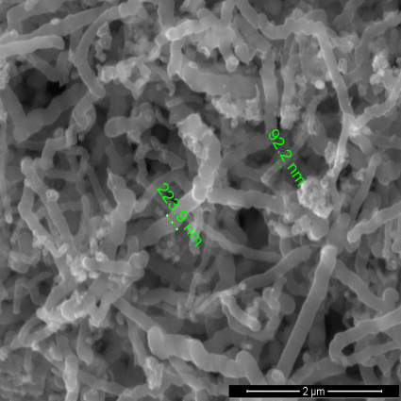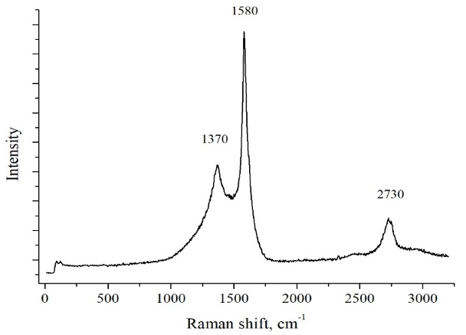
Figure 1 - Electron microscopic images (a) and Raman spectra (b) of CNT
Thus, the proposed method of carbon nanotubes is based on the method of chemical (catalytic) vapor deposition, which is the most promising method of industrial production and provides a product with relatively high layering and homogeneity of the fraction, which determines the achievement of the strength characteristics of structural materials..
Bibliography

Romanenko A.V., Simonov P.A. Carbon materials and their physical and chemical properties: Tutorial. Under red. of Noskov A.S. 2007. P. 128

