Investigation of the destruction process of materials by electro-physical non-destructive testing and diffraction of thermal neutrons
Ayman Ahed Abu Ghazal¹
PhD in engineering sciences
E–mail: gazal.ayman@yandex.ru
Surin Vitaly Ivanovich¹
PhD in engineering sciences, Associate Professor
E–mail: visconst@rambler.ru
Bokuchava Gizo Damirovich²
PhD in Physico-mathematical sciences, Section Leader
E–mail: gizo@nf.jinr.ru
Papushkin Igor Viktorovich²
Engineer
E–mail: piv@nf.jinr.ru
¹National Research Nuclear University «MEPhI», Moscow, Russia
²Joint Institute for Nuclear Research, Dubna, Russia

The process of destruction of a sample of brass-59 at high degree of deformation is investigated. The results of physical and mechanical tests for failure in the range of applied stresses 50÷500 MPa obtained synchronously by two experimental methods: scanning contact potentiometry (SCP) and thermal neutron diffraction (Fig.1).
Neutron diffraction experiments were carried out on the Fourier stress diffractometer FSD at the pulsed fast reactor IBR-2 in the Frank laboratory of neutron physics in Joint institute for nuclear research (Dubna city) [1]. The sample was subjected to an external uniaxial tensile load in situ in a neutron beam using the LM-29 testing machine. The diffraction spectra at each load value on the sample were recorded by detectors at the scattering angles 2Ѳ=±90º.
Potentiometric measurements are performed using the Spectroelph-FRR desktop instrument designed for spectral analysis of electrical signals, In the laboratory ElphysLAB, National Research Nuclear University MEPhI (Moscow Engineering Physics Institute), developed a desktop placement device for spectral analysis of functional diagnostics electrophysical signals Spectroelph. The device is intended for use when working on materials testing machine with horizontally mounted specimens [2].
The device works in conjunction with the hardware and software complex of the mobile diagnostic system located on the laptop Asus x554l. A programmable amplitude discriminator (PAD) of measuring signals with an adjustable scale of amplitude discrimination in the range of 40 dB was developed for measurements in the mode of automated detection. The discriminator cuts off the values of the signal amplitude exceeding the specified level, which allows studying the distribution of the surface electric potential at different structural levels of the signal (SLS).
Use SCP method opens up opportunities to study surface stresses distribution and deformations, mechanisms of plastic deformation, stages of development of internal defects leading to material destruction, and other physical processes [3].
During materials testing, the scanning transducer slides translationally in the horizontal direction along sample surface. This was achieved by screw mechanism and mechanical actuator from stepper motor. The carriage with the electro-physical sensor moves forward along two cylindrical rails. Three supports rotation are used on each side of a screw mechanism, and rails. Measuring rod, telescopic type, with a needle transducer is mounted on the console and pressed to the surface of sample by load, fixed on the spiral spring. The main technical characteristics of Spectroelph are shown in the table, information-measuring system with the device shown in figure 2.

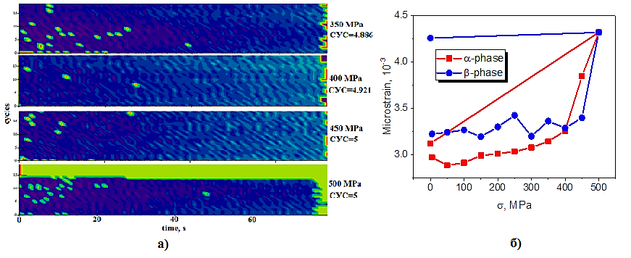
a) b)
Fig.1 a): Linear-time potentiograph of sample surface brass-59 in loading range (350 to 500 MPa) in the band of SLS «4.886»,«4.921»,«5».
b): Averaged over all (hkl) micro-deformation, estimated from the broadening of diffraction peaks.

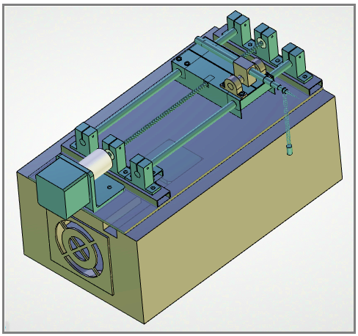
Fig.2. Device for spectral analysis of electro-physical diagnostic signals Spectroelph-FRR

REFERENCES
1. G.D. Bokuchava, V.L. Aksenov, A.M. Balagurov et al, «Neutron Fourier diffractometer FSD for internal stress analysis» // Materials Science & Processing,- Germany, 2002.
2. V.I. Surin, A.A. Abu Ghazal, E.V. Voloshin, E.Y. Telnov, D.O. Titovets, «Device’s for measuring contact surface stress»// Journal of Advanced Research in Technical Science, -North Charleston 2017.
3. A.A. Abu Ghazal, Bokuchava, G.D. I.V. Papushkin, V.I. Surin, Testing of austenitic steel H18N10T for destruction using scanning contact potentiometry and thermal neutron diffraction. - In Sat: Doc. XIII International Scientific and Practical Conference "The Future of Atomic Energy - Atomfuture". Obninsk: IATE NRNU MEPI, 2017, p. 11-13.

