Weak multiplexing in neural networks: Switching between chimera and solitary states
Mikhailenko M.D.¹, Ramlow L. ², Jalan S.³, Zakharova A.²
¹student, ²student
¹Laboratory of Solution Chemistry of Advanced Materials and Technologies, ITMO ²Institut für Theoretische Physik, Technische Universität Berlin ³Complex Systems Lab, Discipline of Physics, Indian Institute of Technology Indore
E–mail: mikhailenko@scamt-itmo.ru
Multiplexing is an important concept used in computational modelling of networks, which allows us to study layer-to-layer interactions. By using the model FitzHugh-Nagumo of a biological neuron, we created a two-layer system with nonlocal coupling in the oscillatory regime (Fig.1). Each layer of the system consisted of 300 oscillators, coupled identically. By investigating such system, we were able to study the effect of weak multiplexing, i.e., when the coupling be- tween the layers is smaller than that within the layers, on the existence of chimera states. We demonstrate new strategies of control for such spatial-temporal patterns, where desired patterns in one layer can be achieved without changing the parameters of the other layer. These phenomena are shown not only for a case of weak multiplexing between the layers, but also for the strong coupling case, when the interlayer coupling strength is equal to intralayer.
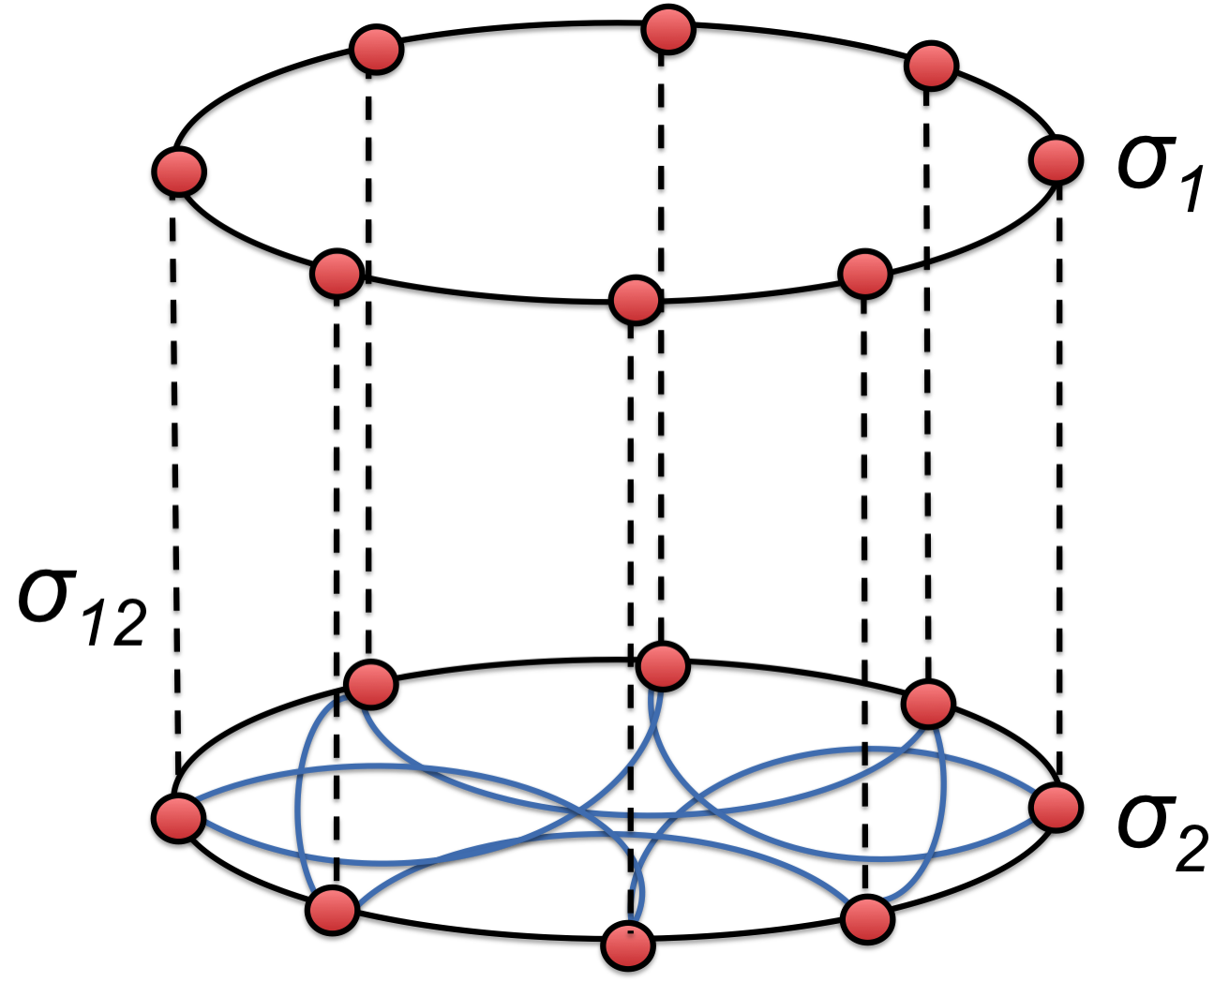
Fig. 1. Schematic model of the system
It has been observed that in the case of coupling range mismatch between the layers, weak multiplexing leads to the appearance of chimera states, which exhibit different shapes of the mean velocity profile for parameter ranges where they do not exist in isolation. Moreover, we show that introducing coupling strength mismatch between the layers can in some cases suppress chimera states and induce various other regimes such as in-phase synchronization or two-headed chimeras. Interestingly, small intra-layer coupling strength leads to the appearance solitary states throughout the whole network.
This work was supported by the German Academic Exchange Service (DAAD) and the Department of Science and Technology of India (DST) within the PPP project (Grant No. INT/FRG/DAAD/P-06/2018) and by the Deutsche Forschungsgemeinschaft (DFG) (German Research Foundation) (Project No. 163436311-SFB 910).

Literature
- M.Kivelä et al. Multilayer networks // Journal of Complex Networks. 2014. V.2 (3). P.2406-2420.

- M. Mikhailenko, L.Ramlow, S.Jalan, A. Zakharova. Weak multiplexing in neural networks: Switching between chimera and solitary state// Chaos. 2019. V. 29 (023122).

