The Mental Representation of Polysemous Adjectives
Korotkaya Maya Borisovna
Student of National Research University Higher School of Economics, Moscow, Russia

Experimental studies on polysemy show that mental representations of literal senses of words with multiple senses are shared with metonymic ones and metaphorical senses are stored separately. However, before now relations among only literal, metonymic and metaphorical senses were examined [Lopukhina, A., Laurinavichyute, A., Lopukhin, K., and Dragoy, O., 2018]. LexType researches demonstrate that a word can have many literal senses – frames [Rakhilina, E., & Reznikova, T., 2016].
Frames in a nutshell: raise a hand, my arm is broken – for both, hand and arm, there is one Russian equivalent ‘ruka’. Does it mean that Russian don’t see the difference? Of course, no. These two different frames (literal senses) are combined in Russian in one word, but we still can recognize them since they occur in different contexts: Russian say ‘pomoy ruki’ (wash your hands), and it doesn’t mean that you have to wash your whole arms, on the other hand ( ☺ ), we say ‘tatu na ruke’ (tattoo on an arm) and mean a whole arm. The thing is: if we find out that different frames are stored separately in our minds (like ordinary different words ‘hand’ and ‘arm’ do), it will be one more reason to believe that all people whatever language they speak have the same lexical system in mind.
This study aims to establish relations among different literal senses of russian adjectives and compare them with relations between literal and metaphorical senses.
We ran an acceptability judgment experiment (as Klein, D. K., and Murphy, G, 2001) in young adults (18-40 years). Our stimuli are pairs adjective+noun, where a noun is an disambiguate context for an adjective, so, an adjective is presented in two literal senses and one metaphorical. Thus, we have three conditions:
- the first literal sense is compared to the first literal sense
- the first literal sense is compared to the second literal sense
- the first literal sense is compared to metaphorical sense
We used latin square design and put our 35 stimuli in three lists. Also we mixed them with 70 fillers, part of which were meaningful and the other were meaningless. Since we put the pairs in order (two neighboring pairs have to share an adjective) we suppose that the prime help an examinee to comprehend a target. If it takes a long time (more than in the first condition) to comprehend the second pair in the second condition, it means that different literal senses of an adjective are stored separately and if it takes the same time, then literal senses share one mental representation. Besides, we compared the time with the time which we got from the third condition: it seems to us that in any case it takes more time to comprehend a metaphor than another literal sense. Moreover, we measured accuracy of the answers and compared the numbers of right answers. The first condition was the basic one.
We used IbexFarm, which allowed us to collect data online. Our subjects were 90 native speakers from 18 to 40 y.o. (mostly students under 25 y.o.) without serious mental diseases.
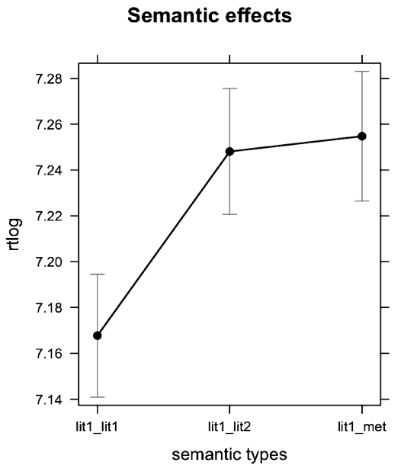
Pic.1

For analysis we used R (R Core Team, 2016) and made mixed linear model (pic.1). Our work showed that there is a significant difference between the first (basic) condition and both the second and the third conditions. This result means that different literal senses (frames) are stored separately in our minds.

Literature
Klein, D. K., and Murphy, G. The representation of polysemous words // Journal of Memory and Language 45, 2001. P. 259–282. doi: 10.1006/jmla.2001.2779
Lopukhina, A., Laurinavichyute, A., Lopukhin, K., and Dragoy, O. The Mental Representation of Polysemy across Word Classes. // Frontiers in Psychology, 9, 2018. P. 192.
Rakhilina, E., & Reznikova, T. (2016). A Frame-based methodology for lexical typology. // P. Juvonen & M. Koptjevskaja-Tamm (Eds.), The Lexical Typology of Semantic Shifts (Pp. 95–129). Walter de Gruyter GmbH & Co KG.

