Photocatalytic Regulation of Autocatalytic Wave of Spatially Propagating Enzymatic Reactions
Lanchuk Y.V. ^{[a]}, Scorb E.V. ^{[a]}, Nikitina A.A. ^{[a]}, Brezhneva N.Y. ^{[a]}, Semenov S.N. ^{[b]}
Master student
^{[a]} Saint-Petersburg National Research University of Information Technologies, Mechanics and Optics (ITMO University), ^{[b]} Harvard University, Cambridge, USA
Department of Chemistry and Molecular Biology, Saint-Petersburg, Russia
E–mail: lanchuk@scamt.ru
Bioinspiration is an attractive topic due to a lot of new functions for a robust chemistry (ChemRob). In nature network of chemical reactions determines “life”. Thus it is attractive to combine different functional ChemRobs in one network with a new function. We use two ChemRobs of i) photocatalytic system, and ii) network of enzymatic (trypsin) reactions aiming for a photocatalytic regulation of autocatalytic wave. We present a regulation of photoactivity of TiO₂ via buffering of protons in polyethylenimine (PEI) layer that suggested as an important for regulation of photocatalytic activity and mild not destructive autocatalytic wave regulation due to a local slow acidification rather that degradation of enzymatic species. Layer-by-Layer assembly of polyelectrolytes (polystyrene sulfonate (PSS)/PEI) around TiO₂ allow to decrease drastically photoactivity and photocurrent of titania due to preferable proton accumulation not on titania but on PEI proton sponge layer. This is an important finding for further use generated on titania surface pH gradient to effect the biochemical reaction rather than photodegradation.
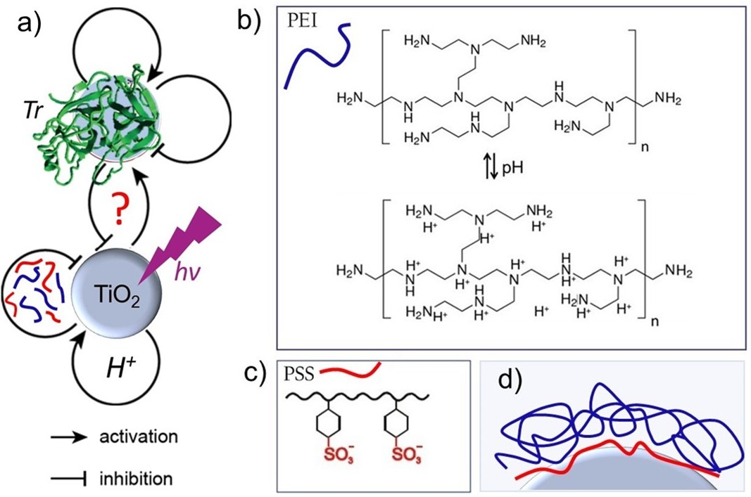
Figure 1. Idea of making a robust chemistry (ChemRob) networks either accelerating or inhibiting each other: a) schematic presentation of a system activation or inhibition, b) PEI layer is known as a proton sponge layer and is pH sensitive, c) PSS is not pH sensitive and might d) separate in space TiO₂ and PEI, thus to take from TiO₂ all generated on its surface protons that is negative feedback to photoactivity of titania.

