Исследование оптических свойств GaAs_{1-x}Bi_{x} в ближней инфракрасной области
Амири ШД¹
аспирант
Теленков МП^{1,2}
старший научный сотрудник, доцент
Митягин ЮА²
ведущий научный сотрудник
Казаков ИП²
зав. лабораторией
Итодо А¹
студент
Савинов СА²
старший научный сотрудник
¹Национальный исследовательский технологический университет, институт новых материалов и нанотехнологий, кафедра теоретической физики и квантовых технологий, Москва, Россия
²Физический институт им. П.Н.Лебедева РАН, кафедра физики твердого тела, Москва, Россия
amiri_shima_1369@yahoo.com
In the past few years, new III–V alloy semiconductors such as GaAs_{1-x} Bi_{x} has attracted great interest owing to its unique combination of properties that make it potentially useful for devices [1,2,3].
In this work, GaAs_{1-x}Bi_{x} thin films which have grown on GaAs substrate using Molecular Beam Epitaxy (MBE) were investigated using probe technique of optical transmission spectroscopy in the near infrared region. From the transmission spectra, the absorption coefficient was determined and subsequently the band gap energies of the two samples and also GaAs substrate calculated. It was established that the optical band gap for both samples were 1.23 eV and 1.18 eV respectively as well as 1.391 eV for GaAs substrate. The band gap energy reduction rate for the sample of known composition was calculated to be 54 meV/ % Bi which corresponds to the other research [1]. Therefore, this method can later be used to control the composition of a solid solution of GaAs_{1-x}Bi_{X}, i.e. as a method for characterizing epitaxial layers and structures.
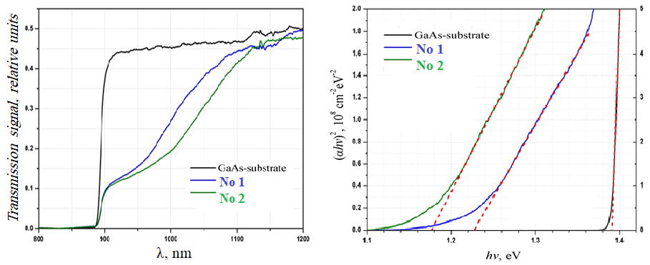
Рис. 1. Transmission spectra of the GaAs_{1-x} Bi_{x} samples (No 1, No 2) and GaAs substrate( left hand) and plot of the quantity (αhν)² versus the (hν)( right hand)

The work was supported by Russian Basic Research Foundation (Project No. 18-02-00842-a).

References
- Nagaraja K K, et al. GaAs(1-x) Bix: A Promising Material for Optoelectronics Applications // J. Crit. Rev. Solid State Mater. Sci. 2017. V 42. P. 239-265.
- Oe K, et al. New Semiconductor Alloy GaAs(1-x) Bix Grown by Metal Organic Vapor Phase Epitaxy // Jpn. J. Appl. Phys. 1998. V 37. P. 1283-1285.
- Fluegel B, et al. Giant Spin-Orbit Bowing in GaAs1-xBix // J. Phys. Rev. Lett. 2006. V 97. P. 067205(1)-067205(4)

