Взаимодействие биомембран с целлюлозой. Компьютерное моделирование
Мухамадьяров Е.И.
студент
Санкт-Петербургский государственный университет,
физический факультет, Санкт-Петербург, Россия
E–mail: e.mukhamadiarov@gmail.com
Over last decades a great deal of attention have attracted by biodegradable polymers in view of their high potential for numerous biomedical applications. One typical representative of such natural biodegradable polymers is cellulose[1]. It is important that one of the possible application of composite materials based on cellulose is wound dressing. This technique necessarily includes the contact of the material from cellulose with the cells of a living organism, or more precisely, with cellular membranes.
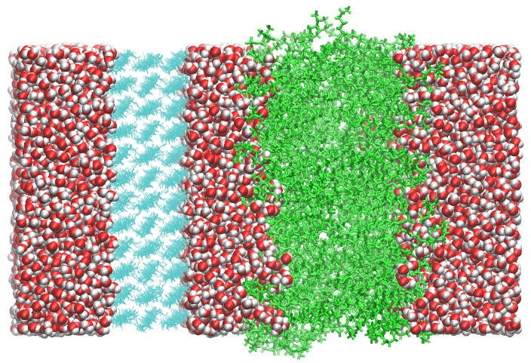
A molecular-level insight into the interactions of phospholipid membranes with cellulose is crucial for the development of novel cellulose-based materials for wound dressing. In this work I employ the state-of-the-art computer simulations to investigate at a qualitative level the interactions between the lipid bilayer consisting of 124 molecules of palmitoyl-oleyl-phosphatidylcholin (POPC) and crystalline cellulose. The latest studies of this system(Fig.1) were carried out in a group of researchers led by Gurtovenko A.A.[2] In their work was shown that for the cellulose-lipid membrane system there are two major types of interactions: (i) direct attractive interactions between lipid choline groups and oxygens of hydroxyl (hydroxymethyl) groups of cellulose and (ii) hydrogen bonding between phosphate groups of lipids and cellulose’s hydroxymethyl/hydroxyl groups. Fig 1. POPC(green) and cellulose crystal(cyan)

In this work I continue to explore possible parameters in this system, but already using the other methods, in this report I use computer simulation for pulling(approaching) the lipid membrane to cellulose crystal. This is interesting because this method has not previously been applied to these systems. To analyze this process, we obtained a series of “umbrella sampling” simulations. Each simulation corresponded to a specific position (distance) of the lipid layer relative to the cellulose crystal. One possible parameter that we can obtained is distribution of free energy as a function of the distance between the lipid membrane and cellulose. Analysis of this parameter can be crucial to insight the evolution of this system and also can predict equilibrium state of the membrane-cellulose system. In its turn, the equilibrium state is the first step to determining the parameters of the lipid membrane, such as, area per lipid or order parameter of tails.
Acknowledgements
My utmost thanks and sincere gratitude go to my scientific adviser, D. of P. M. Sciences, Professor of IMC RAS Gurtovenko A.A., and also Professor Dr. Mikko Karttunen.
This work was supported by the Russian Ministry of Education and Science within State Contract 14.W03.31.001 (megagrant).
Литература
- Doelker E. Cellulose derivatives // Biopolymers I. Berlin/Heidelberg: Springer-Verlag. С. 199–265. V. 124 (4). P. 2406–2420.
- Tolmachev D.A., Lukasheva N.V., Gurtovenko A.A. Molecular-Level Insight into the Interaction of Phospholipid Bilayers with Cellulose // Langmuir. 2017. Т. 33, № 44. С. 12793–12803.

