Microgels are crosslinked particles of big molecular mass notable due to their intermediate position between polymeric macromolecules and solid colloidal particles. This fact defines microgels’ important properties and practical applications. Microgels are widely used to stabilize emulsions. As well the ability to undergo collapse makes them promising candidates in drug delivery, medical, technical and the other applications.
Historically most attention was paid to spherical microgels. They are well studied theoretically, experimentally and by the means of computer modeling. But with the development of fusion technologies increasingly smaller microgels can be produced. So we can choose the form of synthesized microgels and produce, for example, rod-shape microgels using microfluidic methods. Such objects are obtained experimentally, but still there are no theoretical or other researches of their properties.
In this work we focused on non-spherical microgels’ swelling and collapse features. As a simulation object an ellipsoidal microgel was chosen. To conduct the computer simulations two methods were used: dissipative particle dynamics (DPD) and molecular dynamics (MD). Calculations were carried out by means of “Lomonosov” cluster. Quality of the solvent was controlled by the monomer interaction energy. One may suppose that as solvent degrades the microgel will collapse self-similar. Though non self-similar collapse was discovered: microgels demonstrated conformational transition from ellipsoid to sphere while the quality of solvent went downhill. We suppose that such a behavior appeared because of bulk and surface forces competition. In increasingly degradating solvent microgel tended to adopt the least surface energy conformation – the sphere. This result was observed without reference to cross-linking density by both of simulation methods. In this way non-spherical microgels appears to be objects with nontrivial properties and need further investigation.
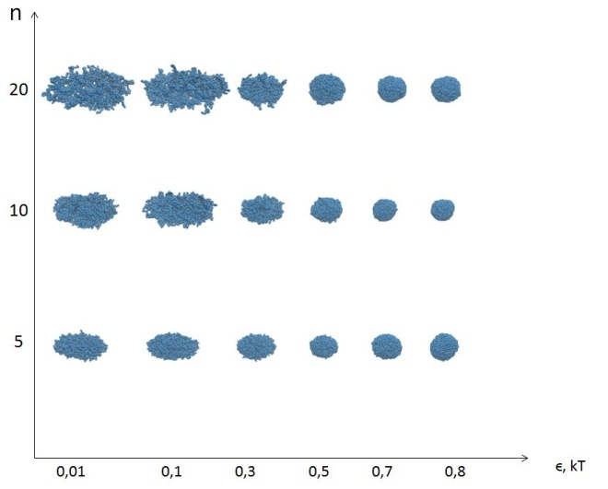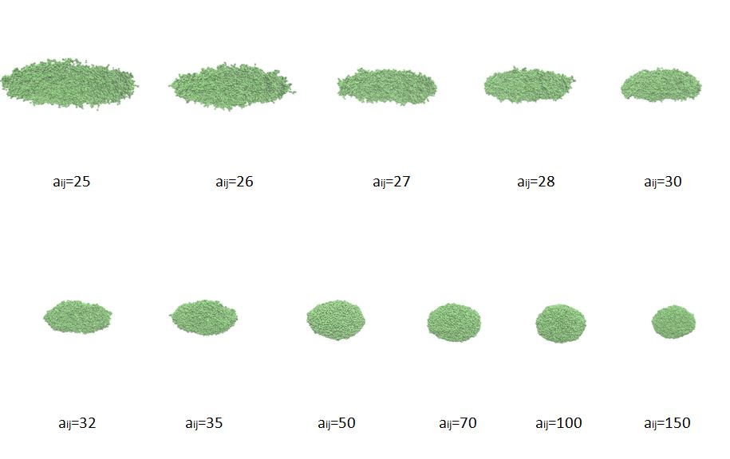
Рис. 1. Результаты моделирования, полученные методом MD (слева) и DPD (справа).

Литература
1. Andreas J. Schmid, Janine Dubbert, Andrey A. Rudov, Jan Skov Pedersen, Peter Lindner, Matthias Karg, Igor I. Potemkin & Walter Richtering Multi-Shell Hollow Nanogels with Responsive Shell Permeability // Scientific Reports 6, Article number: 22736 (2016)

